**Data warehousing & OLAP**

**OLTP (on-line transaction processing)**

* Class of information systems that facilitate and manage transaction-oriented applications, typically for data entry and retrieval transaction processing

(used to ‘run’ a business)

* The system responds immediately to user requests/ online system that requires to response as soon as possible (e.g. university, market, industry-related activities)
* High throughput and insert- or update-intensive database management. These applications are used concurrently by hundreds of users
* Typically, OLTP systems are used for order entry, financial transactions, customer relationship management (CRM) and retail sales. Such systems have a large number of users who conduct short transactions. Database queries are usually simple, require sub-second response times and return relatively few records

Key goals of OLTP applications: availability, speed, concurrency and recoverability (essential for running operation)

Concurrency – make sure that multiple things coming in at the same time, the DBMS can handle those

Recoverability – recover the data, if the system crash

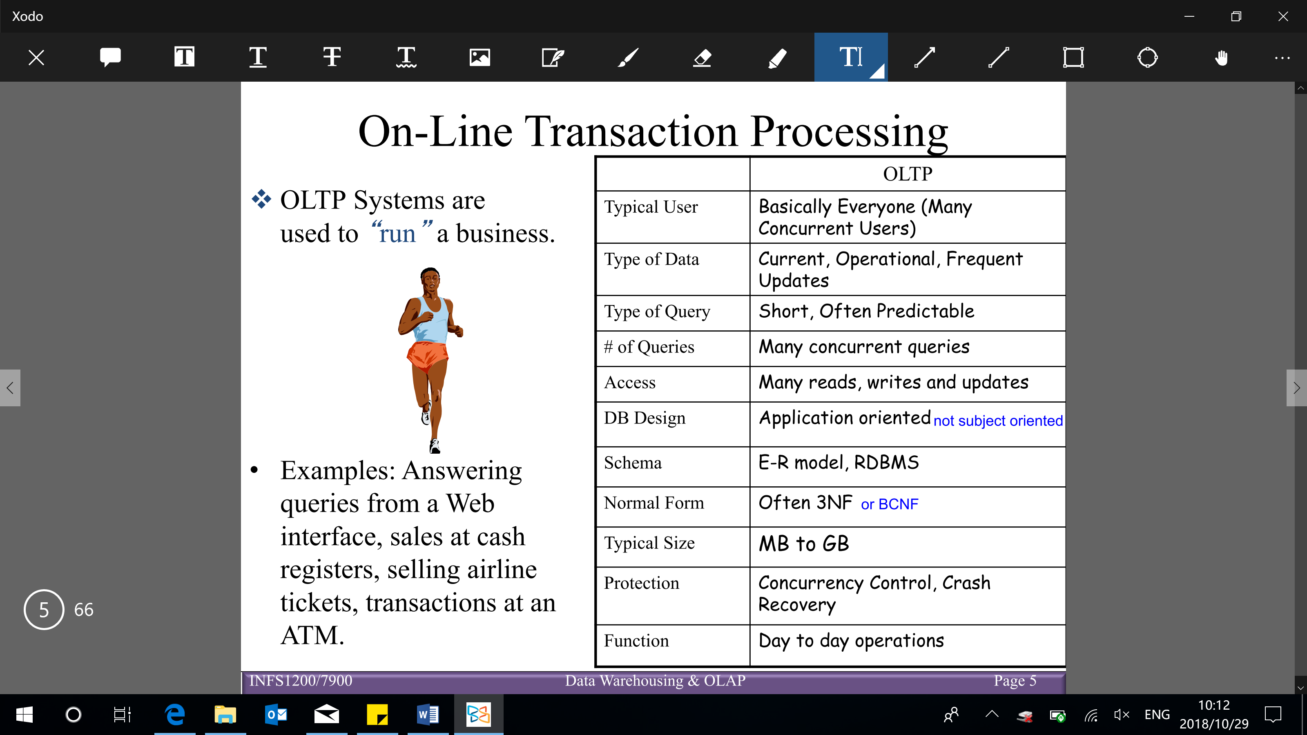

Increasingly, organizations are analysing current and historical data (get more data) to identify useful patterns and support business strategies (use data to make informed decisions about the future of the business)

* ‘Decision support’, ‘business intelligence’
* The emphasis is on complex, interactive, exploratory analysis of very large datasets created by integrating data from across all parts of an enterprise

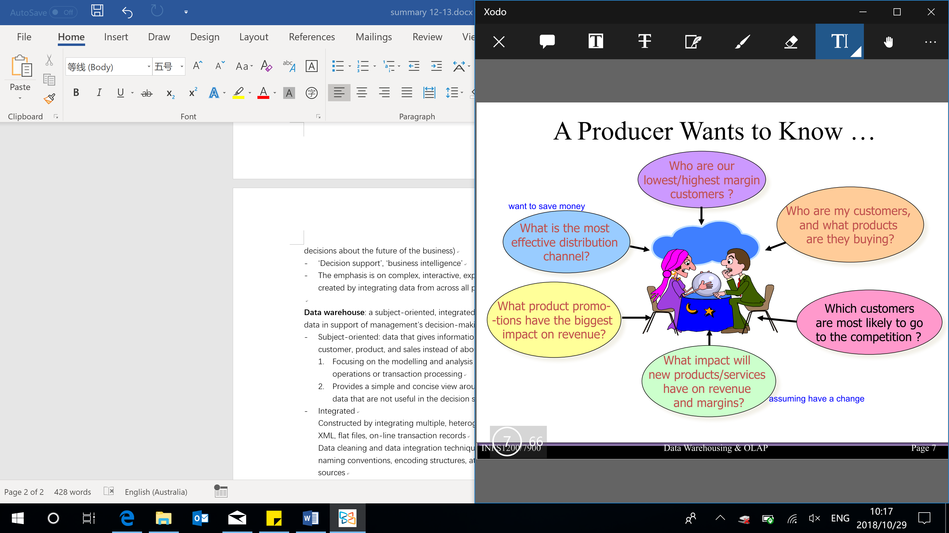

Problems with ‘big data’ (many data):

* Can’t find the data I need
* Can’t get the data I need
* Can’t understand the data I found
* Can’t use the data I found

→ Data warehouse would help to solve these questions

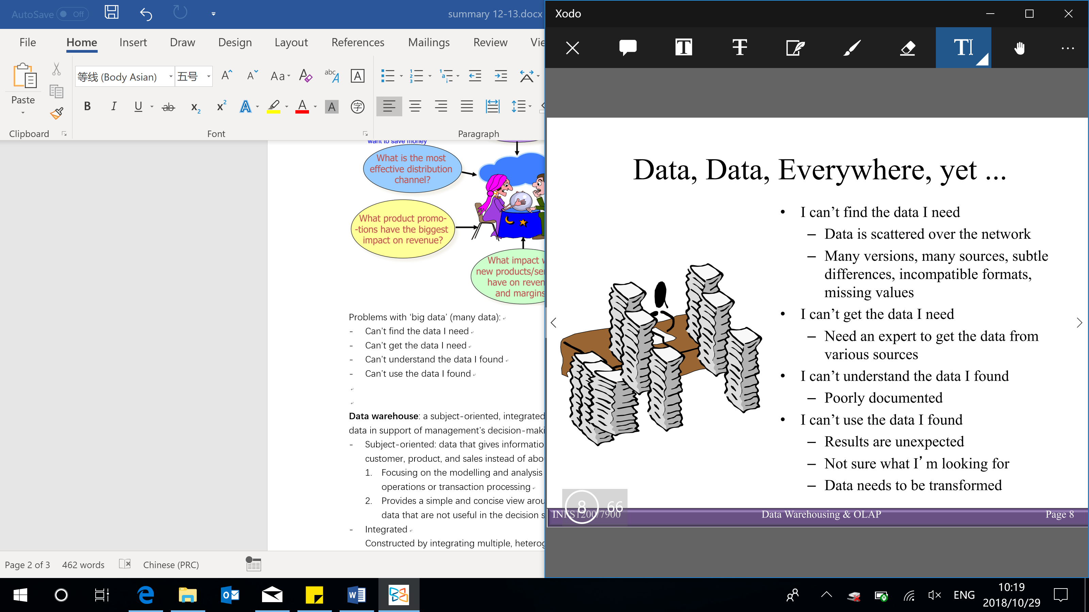

**Data warehouse**: a subject-oriented, integrated, time-variant, and non-volatile collection of data in support of management’s decision-making process

* Subject-oriented: data that gives information about a particular subject area such as customer, product, and sales instead of about a company’s ongoing operations

1. Focusing on the modelling and analysis of data of decision makers, not on daily operations or transaction processing
2. Provides a simple and concise view around particular subject issues by excluding data that are not useful in the decision support process

Application-oriented schema V.S. subject-oriented schema:

* Application-oriented: need to cover everything that happens in the system
* Subject-oriented /data warehouse: look at something in particular (e.g. revenue), summarize the information into one table (more compact table), and only focus on those data

Denormalization – analyse data (summarization) instead of running an operation

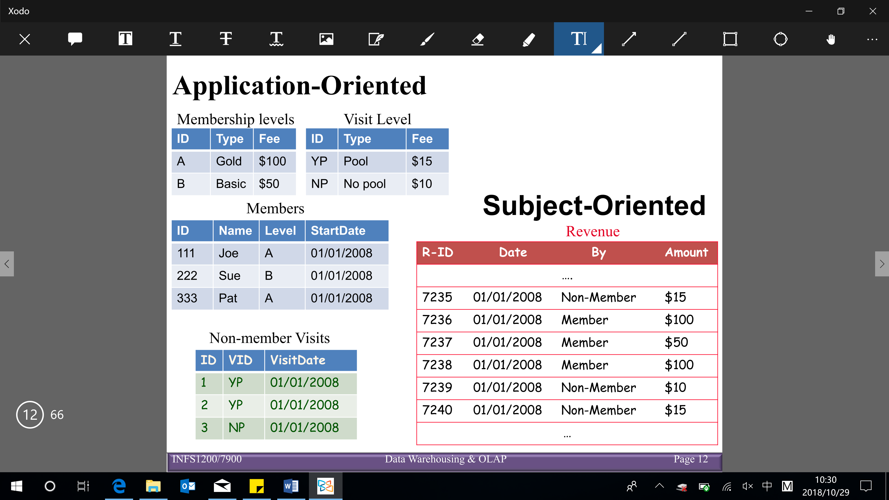

* Integrated

Constructed by integrating multiple, heterogeneous data sources (e.g. relational databases, XML, flat files, on-line transaction records) → aggregate into one big data warehouse

Data cleaning and data integration techniques are applied – ensure consistency in naming conventions, encoding structures, attribute measures, etc. among different data sources (e.g. hotel price depends on currency, various room taxes, whether breakfast or internet is included, etc)

* Time-variant: all data in the data warehouse are associated with a particular time period

The time horizon for a DW is significantly longer than for operational systems

* Operational DB (OLTP): all data is current, and subject to change (historical data is not important, would delete the data)
* DW: contains lots of historical data that may never change (normally not delete any data, just keep adding new data into database), but may have utility to the business when determining trends, outliers, profitability; effect of business decisions or changes to policy; precompute aggregations; record monthly balances or inventory; etc.
* DW data is tagged with data and time, explicitly or implicitly
* Non-volatile: data is stable in a data warehouse. More data is added, but data is not removed → enables management to gain a consistent picture of the business

Real-time updates of operational data typically don’t occur in the DW environment (DW expected that data is stable, however, reason of normalizing when run a system, it’s because it expected that there are lots of insertions and updates), but can be done in bulk later (e.g. overnight, weekly, monthly)

* DW does not require transaction processing, recovery, and concurrency control mechanisms
* DW focuses on 2 major operations: loading of data & accessing of data

2 different types of needs:

* Operational DBMS (for running the data)
* Data warehouse (optimize the business or make data-informed decisions)

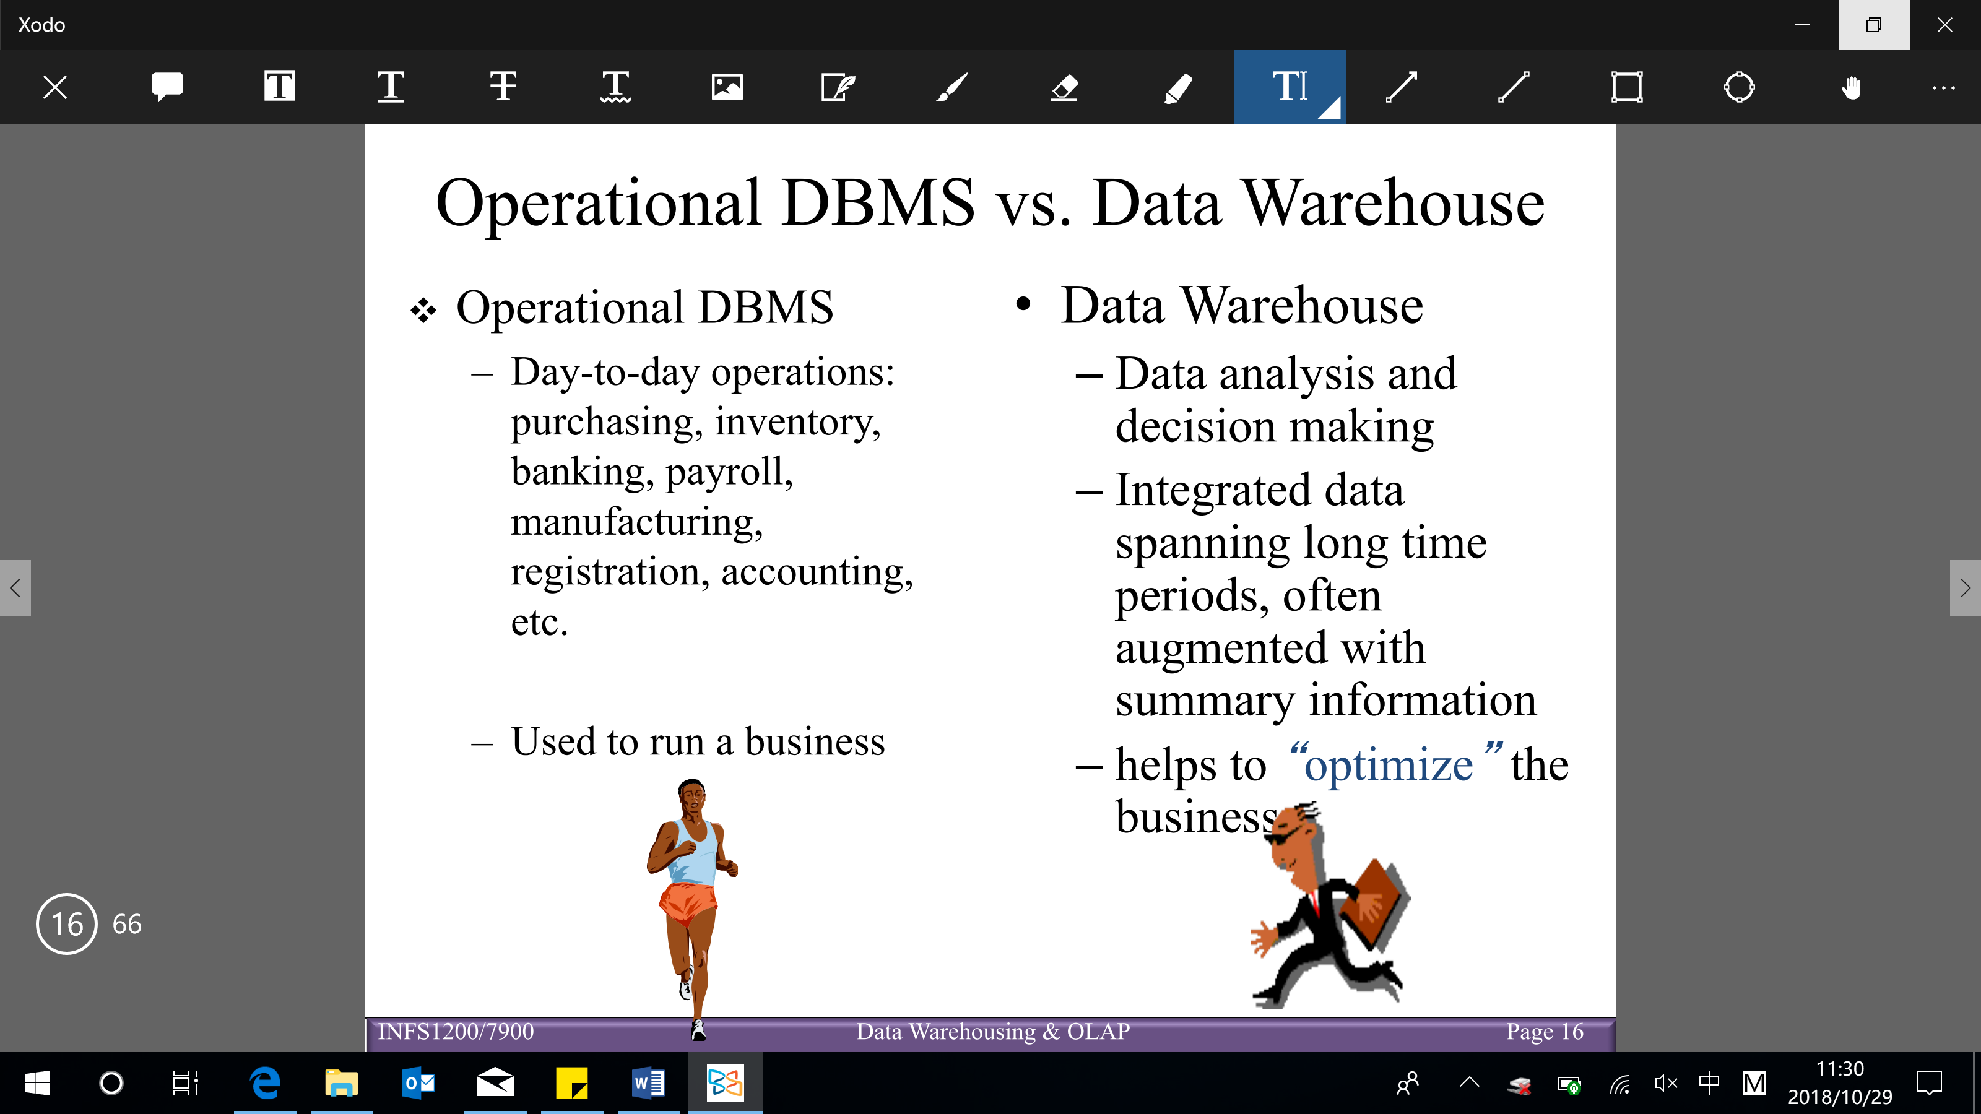

Why separate data warehouse?

* High performance for both systems (operational DBMS & data warehouse)

DBMS (tuned for OLTP): access methods, indexing, concurrency control, recovery (optimize the running of the operation)

Warehouse: needs to be tuned for complex queries, multidimensional views, consolidation (merge/ union)

* Different types of queries

Extensive use of statistical functions which are poorly supported in DBMS/OLTP

Running queries that involve conditions over time or aggregations over a time period, which are poorly supported in a DBMS/OLTP

[Normally the queries run on data warehouse is much slower, because the queries are more complex, BUT it doesn’t mean the data warehouse itself is slower than DBMS]

**OLAP (on-line analytical processing)**: a category of software technology that enables analysts, managers, and executives to gain insight into data through fast, consistent, interactive access to a wide variety of possible views of information

* Technology used to perform complex analysis of the data in a data warehouse
* The data (in general database) has been transformed from raw data to reflect the dimensionality of the enterprise as understood by the user

OLAP queries are, typically:

* Full of grouping and aggregation
* Few, but complex queries – may run for hours
* The natural way to think about such queries is in terms of a multidimensional model, which is an extension of the table model in regular relational databases

This model focuses on (details below):

A set of numerical measures: quantities that are important for business analysis (e.g. sales)

A set of dimensions: entities on which the measures depend on (e.g. location, date)

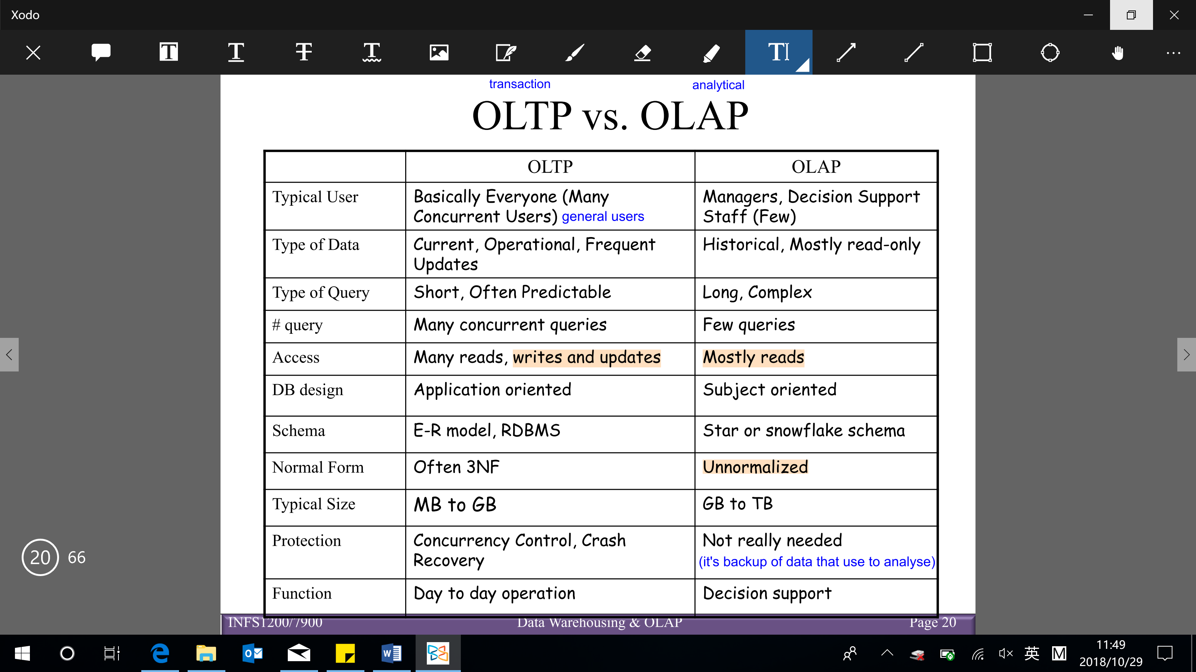

Actionable business intelligence:

* The goal of business intelligence: make strategic business decisions that improve sales, profits, response times, customer satisfaction, customer relationship, etc.

Data warehousing: the process of constructing and using data warehouses

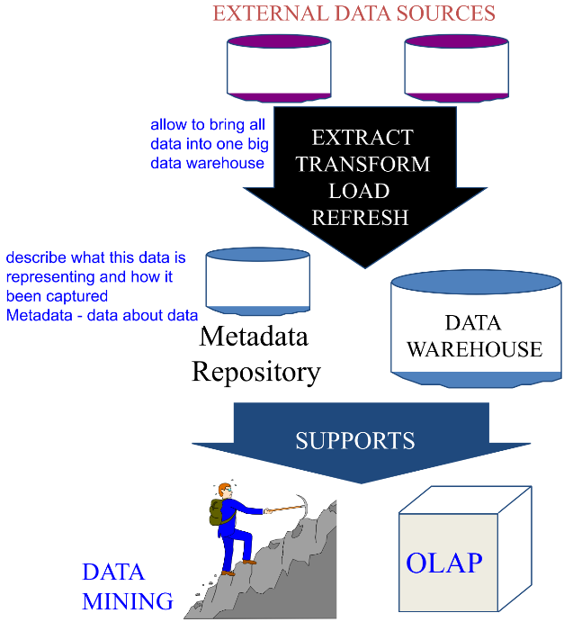

Multidimensional data model (fact table & dimension tables)

Star schema – one table for the fact table (in BCNF) & one table per dimension (not normalized) [fact table references dimension tables – join → filter → group → aggregate]

* The schema that is very common in OLAP applications
* Fact table: the main relation, which relates dimensions to a measure via foreign keys

Fact table has FKs to the dimension tables

Fact tables are much larger than dimensional tables

There can be multiple fact tables

These mappings are essential

* Each dimension can have additional attributes and associated dimension table

(dimension – entity that provide further information

Attributes can be numeric, categorical, temporal, counts, sums)

The dimension tables are small (always not normalize, can have redundancy, as redundancy is less important than good query performance)

Updates/inserts/deletes are relatively less frequent

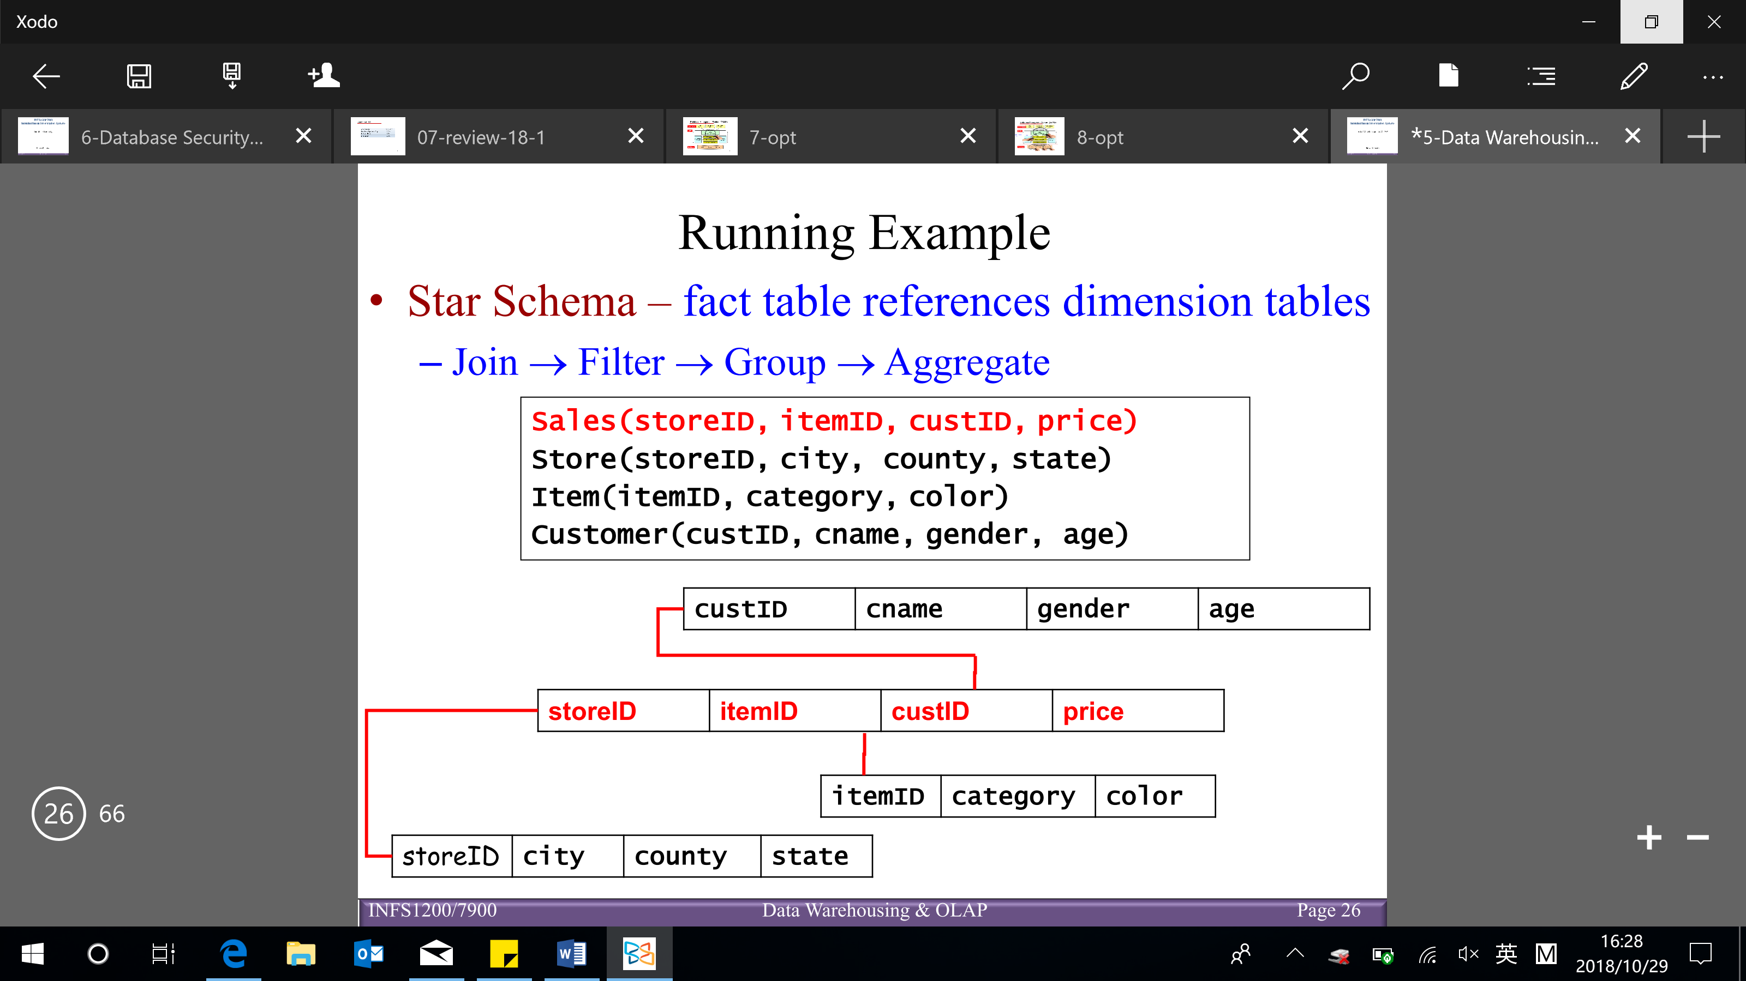

Dimension hierarchies:

For each dimension, the set of values can be organized in a hierarchy

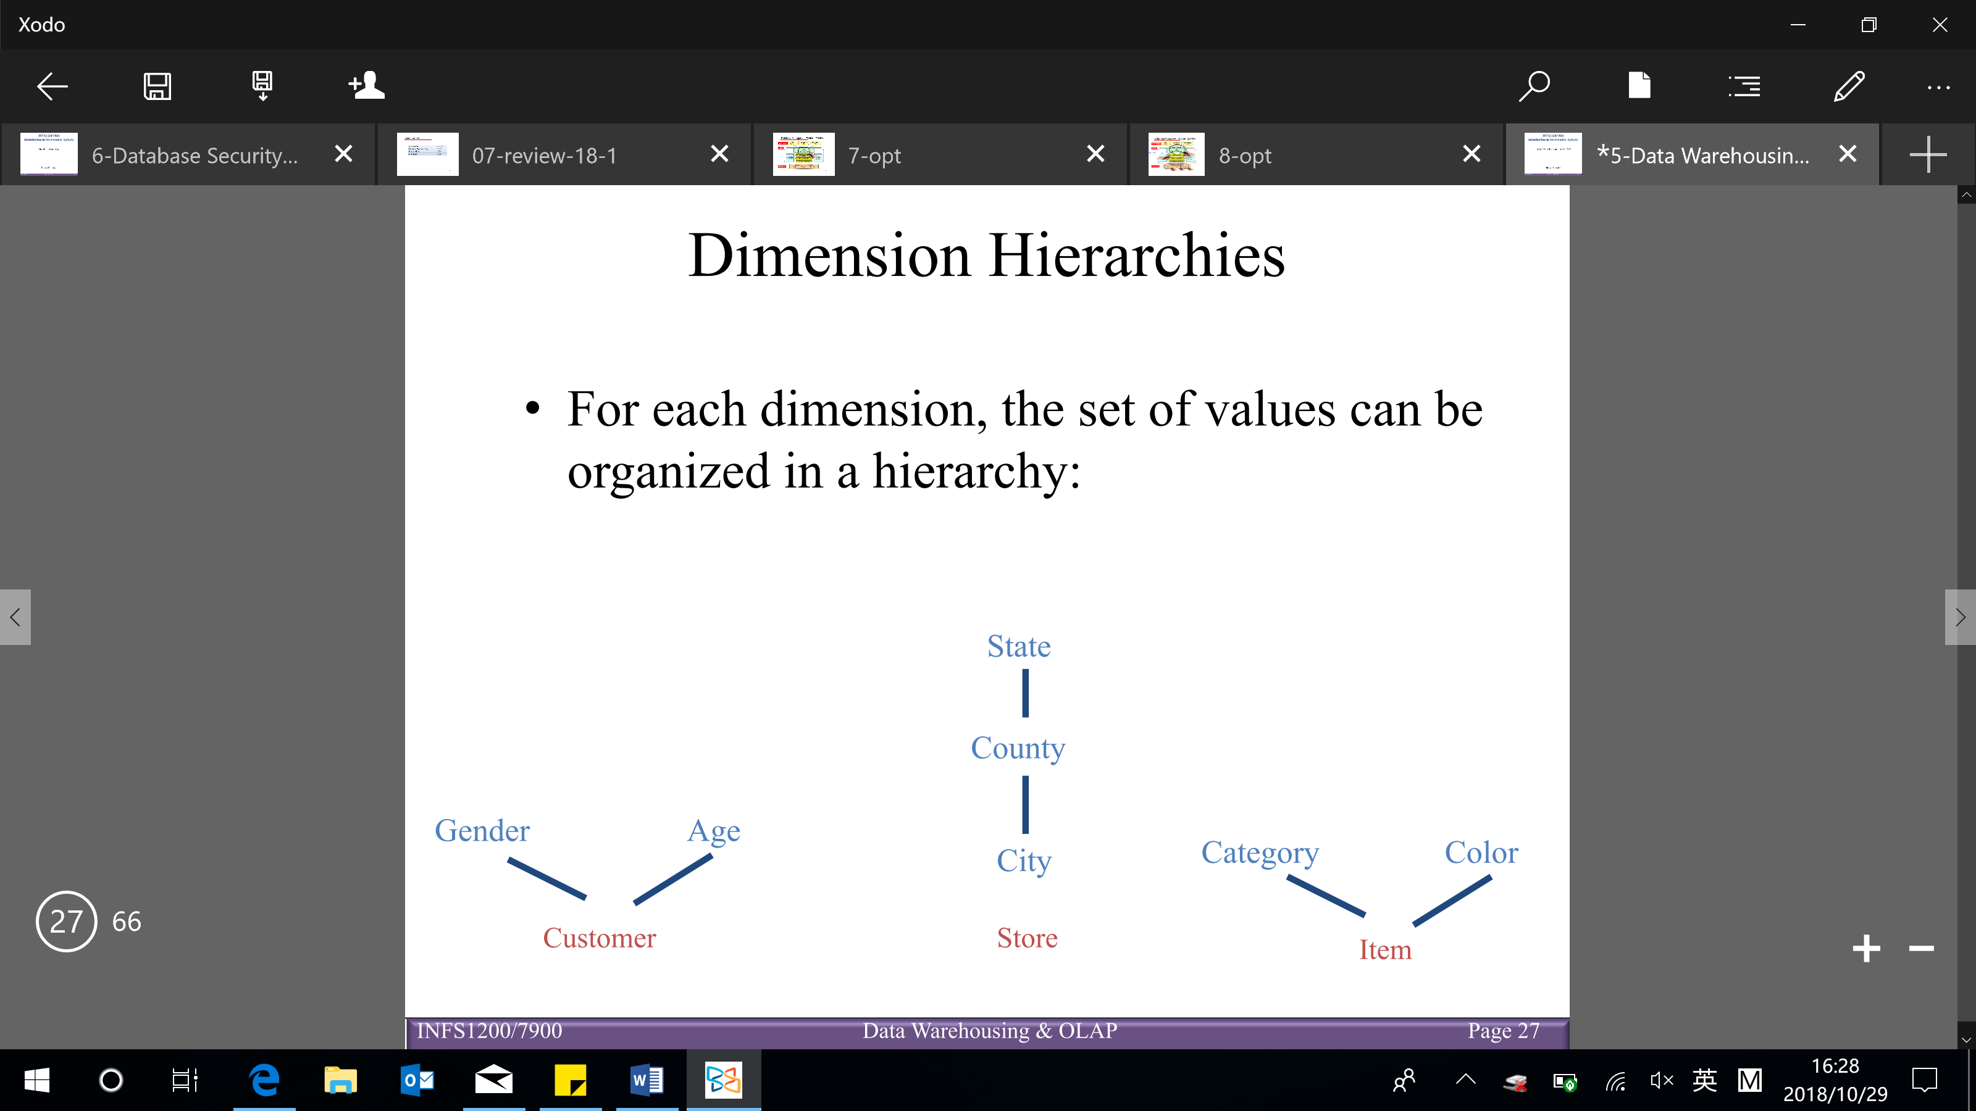

Full star join (join all the tables)

If we join fewer than all dimensions, then we have a star join

In general, OLAP queries can be answered by computing some or all of the star join, then by filtering, and then by aggregating

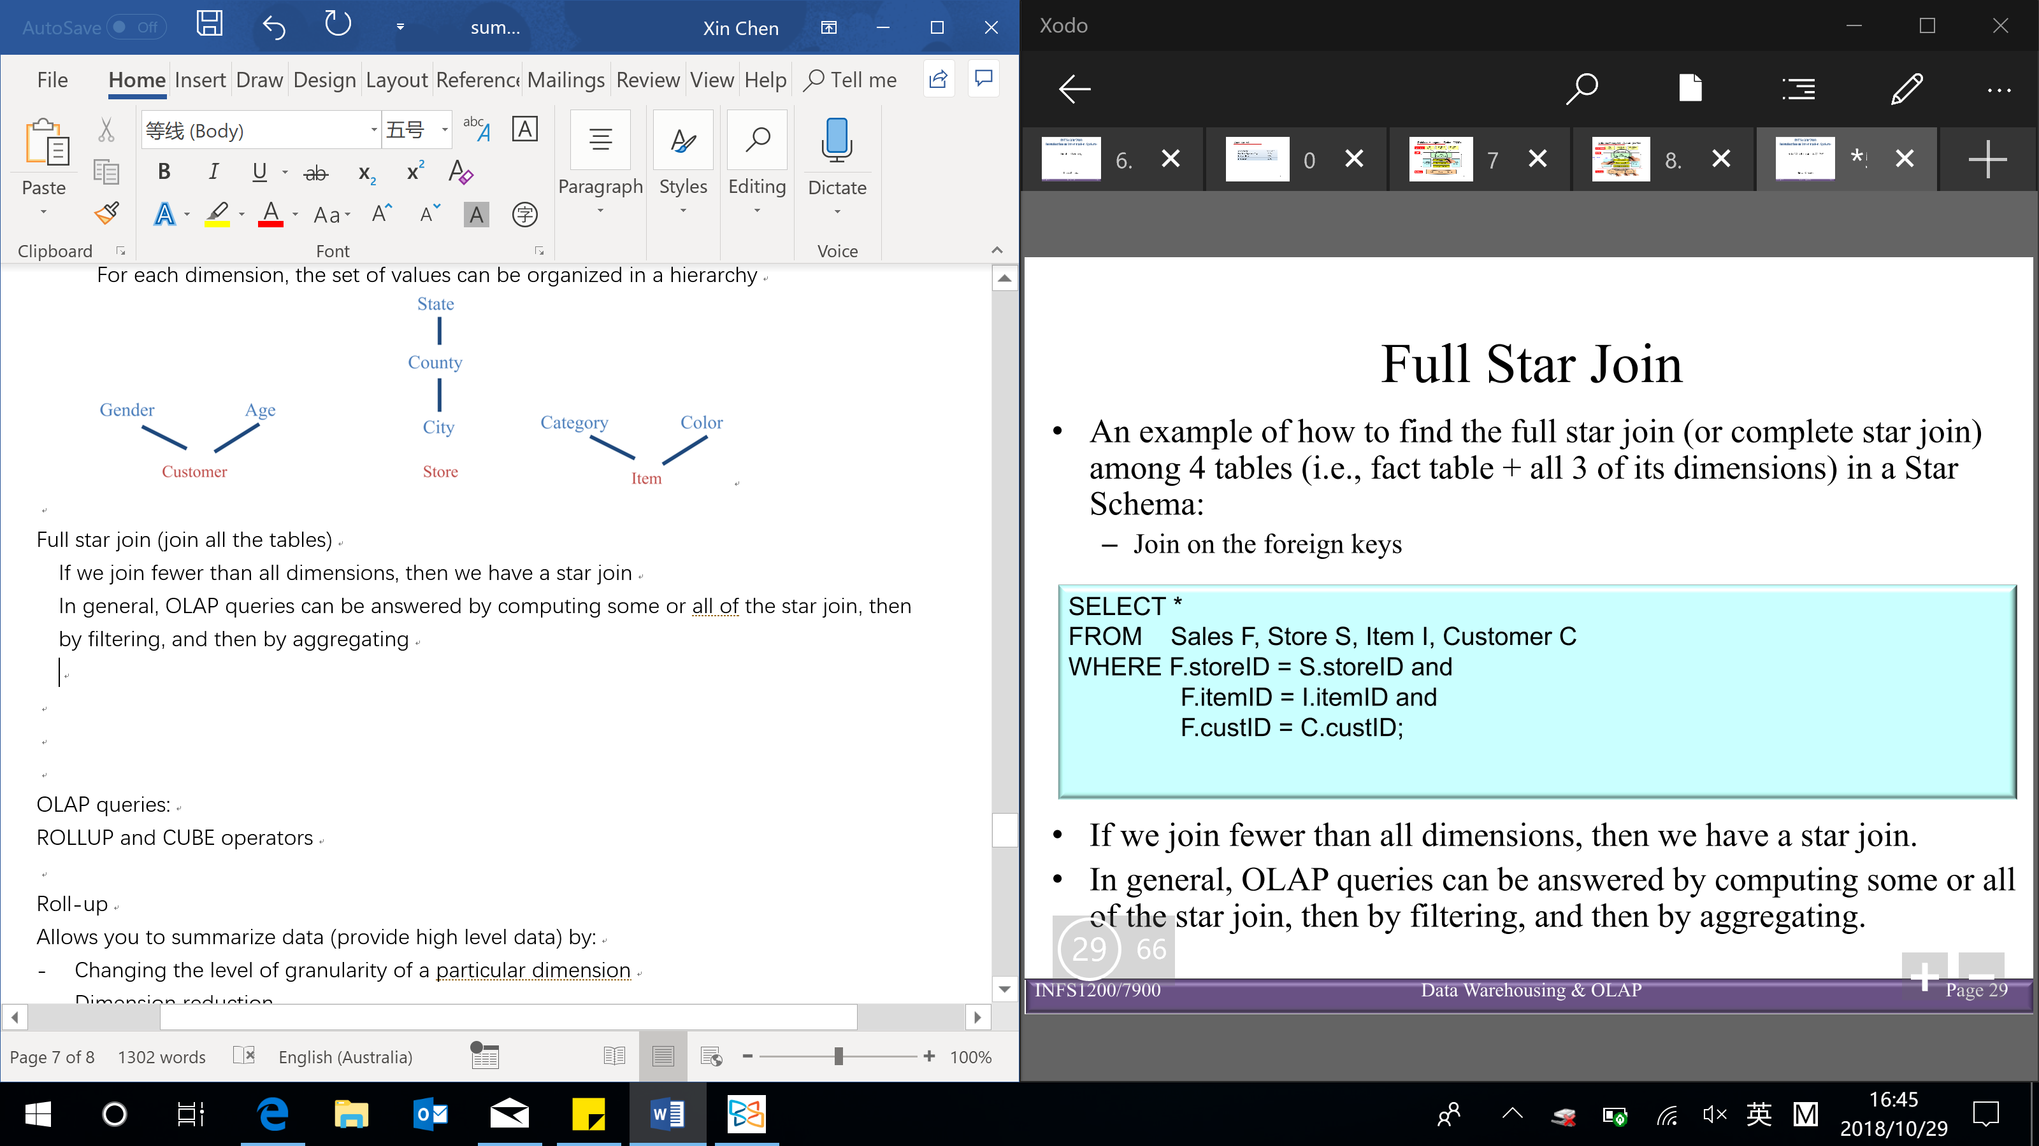

**OLAP queries**: (cannot distinguish them on SQL level)

Roll-up/ drill-down – similar to zoom in/out

Slicing – look into one of the values in one of the dimensions but not zoom in/out

Dicing – look into one of the values in multiple dimensions

Pivoting – rotate the cube

* **Roll-up** – allows you to summarize data (provide high level data) by:
* Changing the level of granularity of a particular dimension (example 1,2)
* Dimension reduction (example 3)

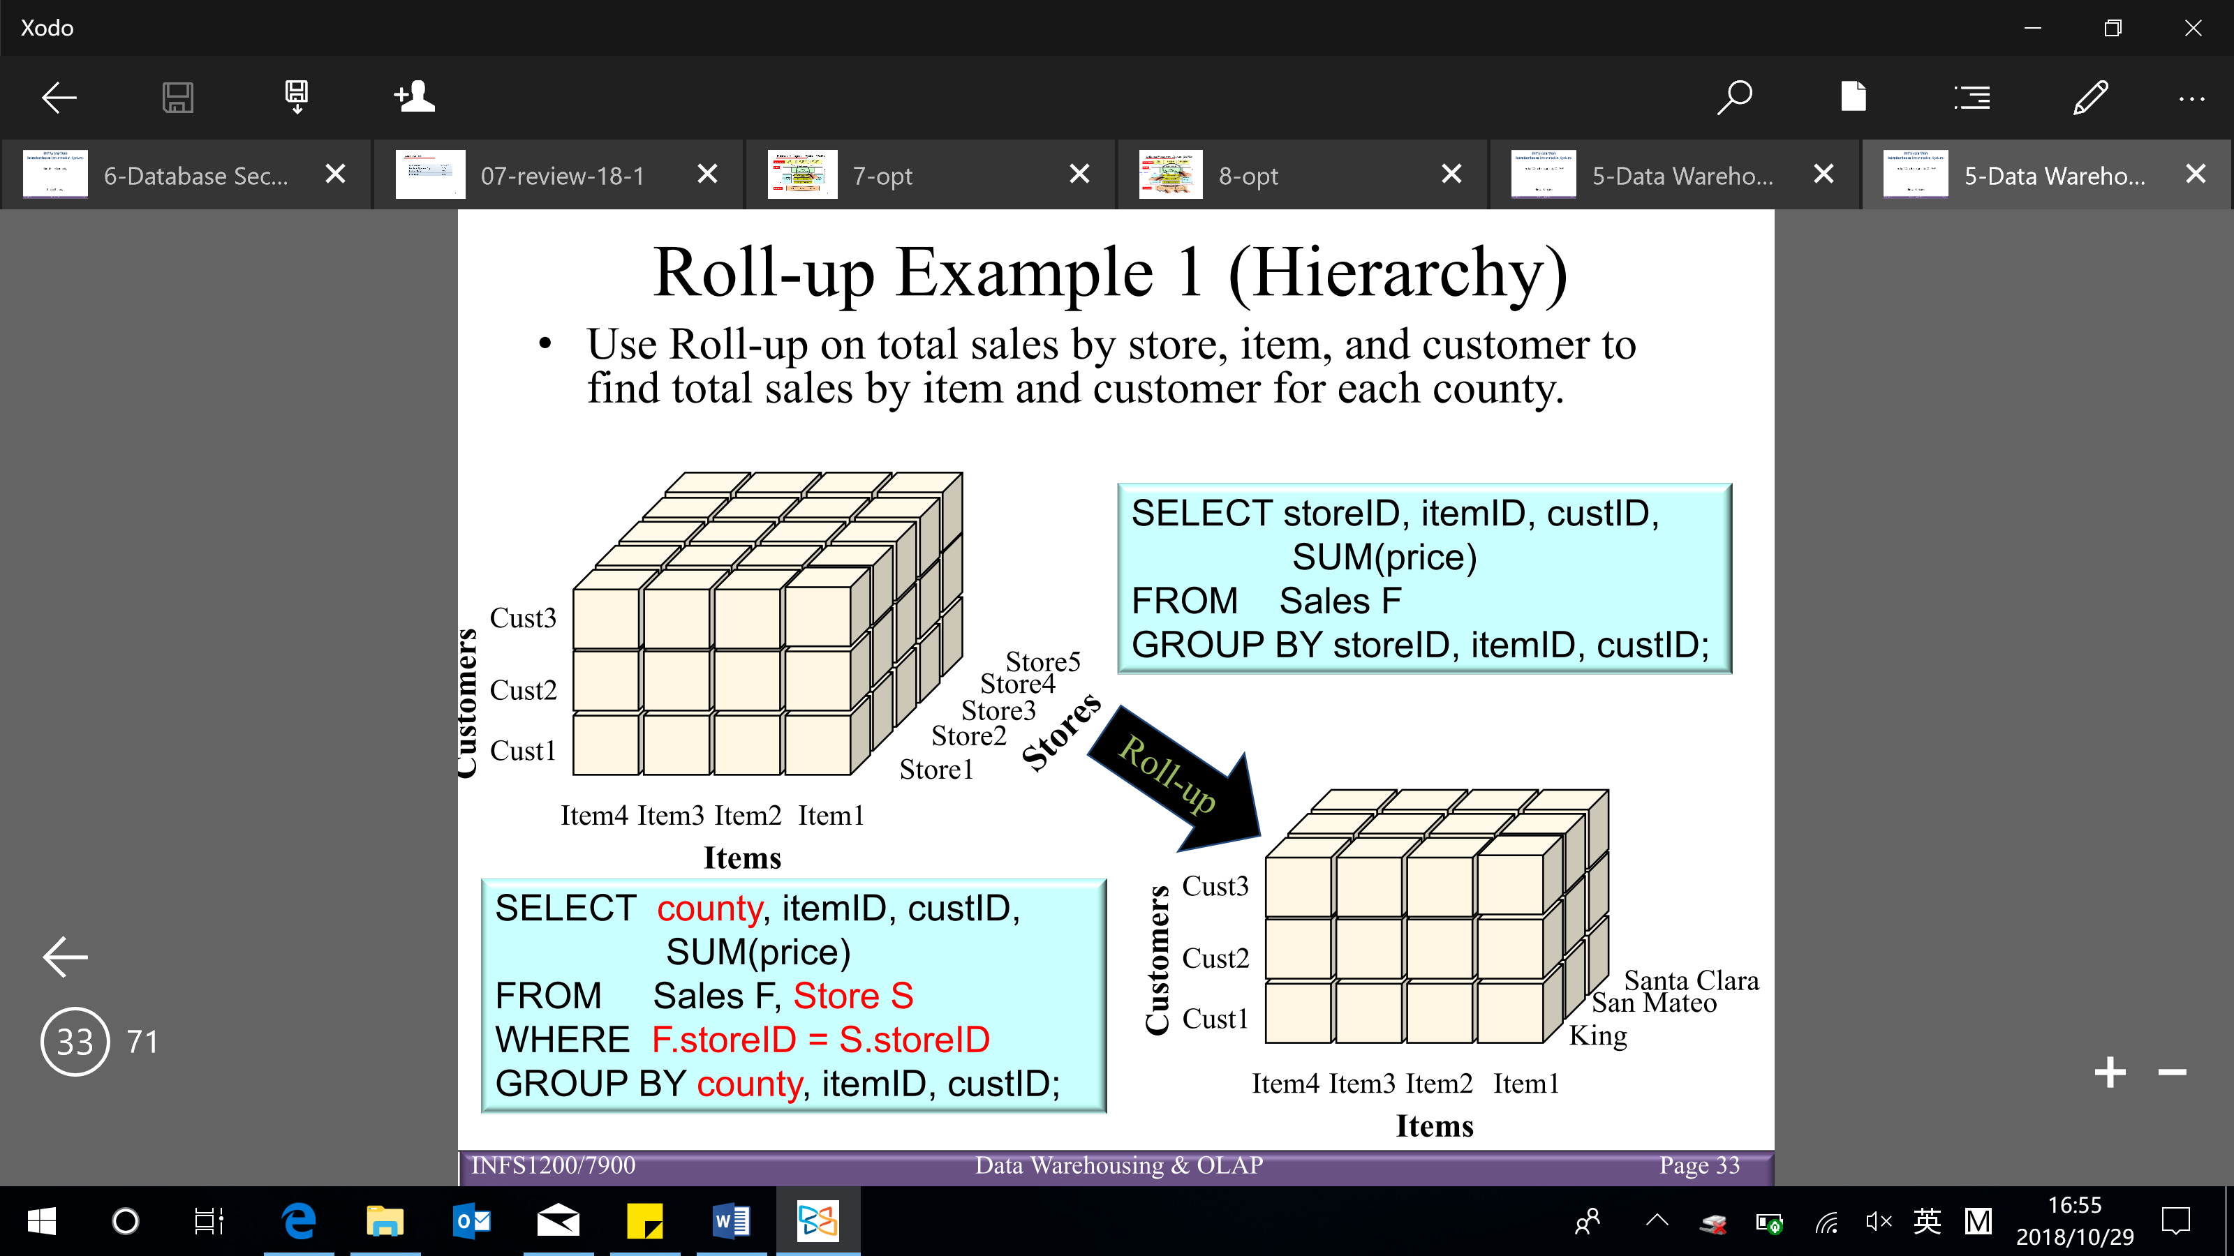

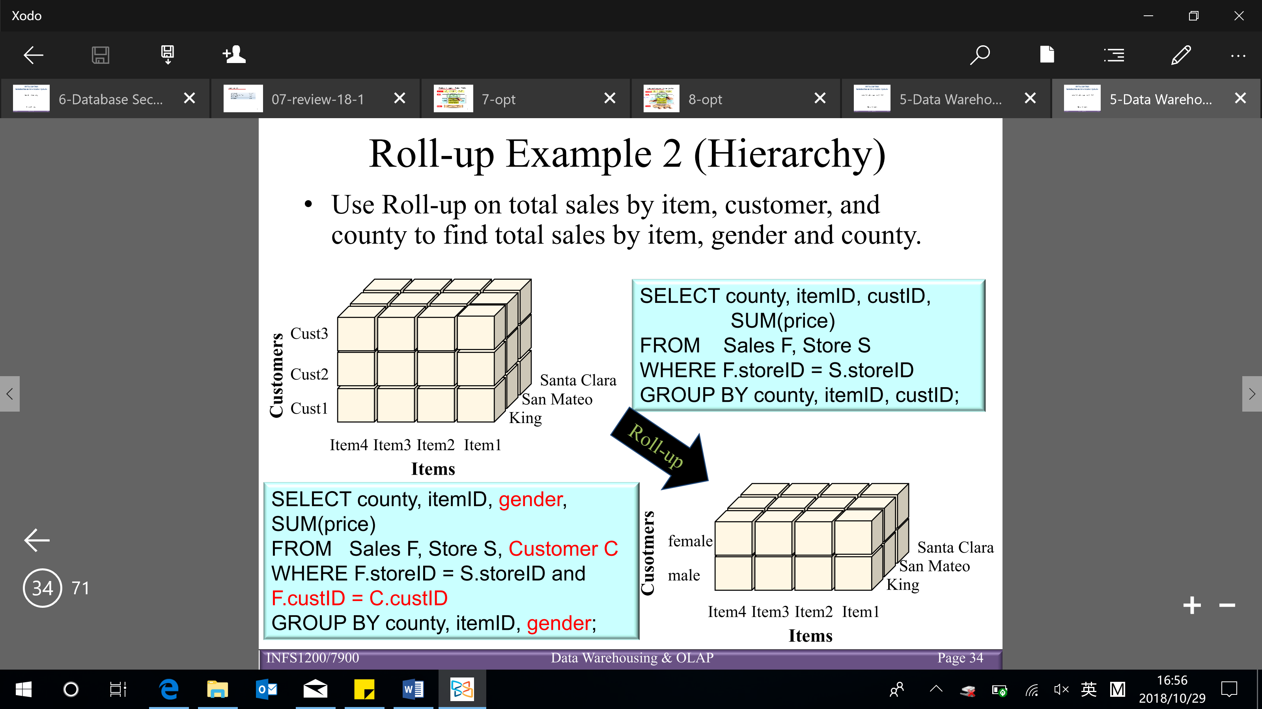

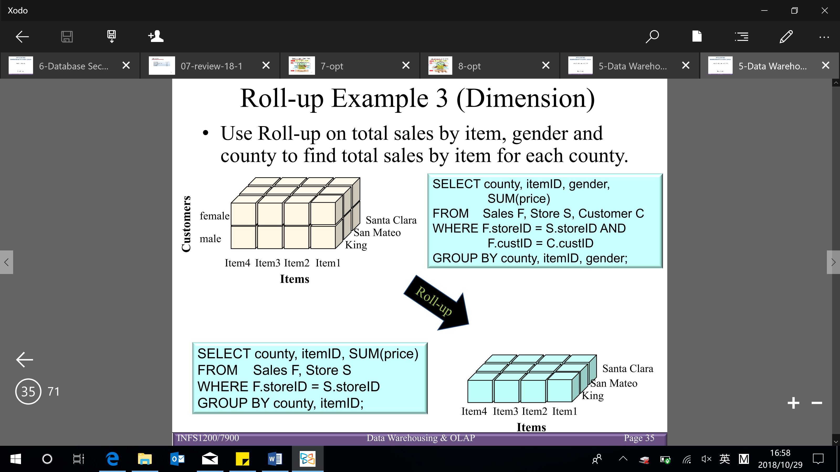

* **Drill-down** – reverse of roll-up (higher level → lower level)
* From higher level summary to lower level summary (e.g. want more detailed data) (example 1)
* Introducing new dimensions (example 2)

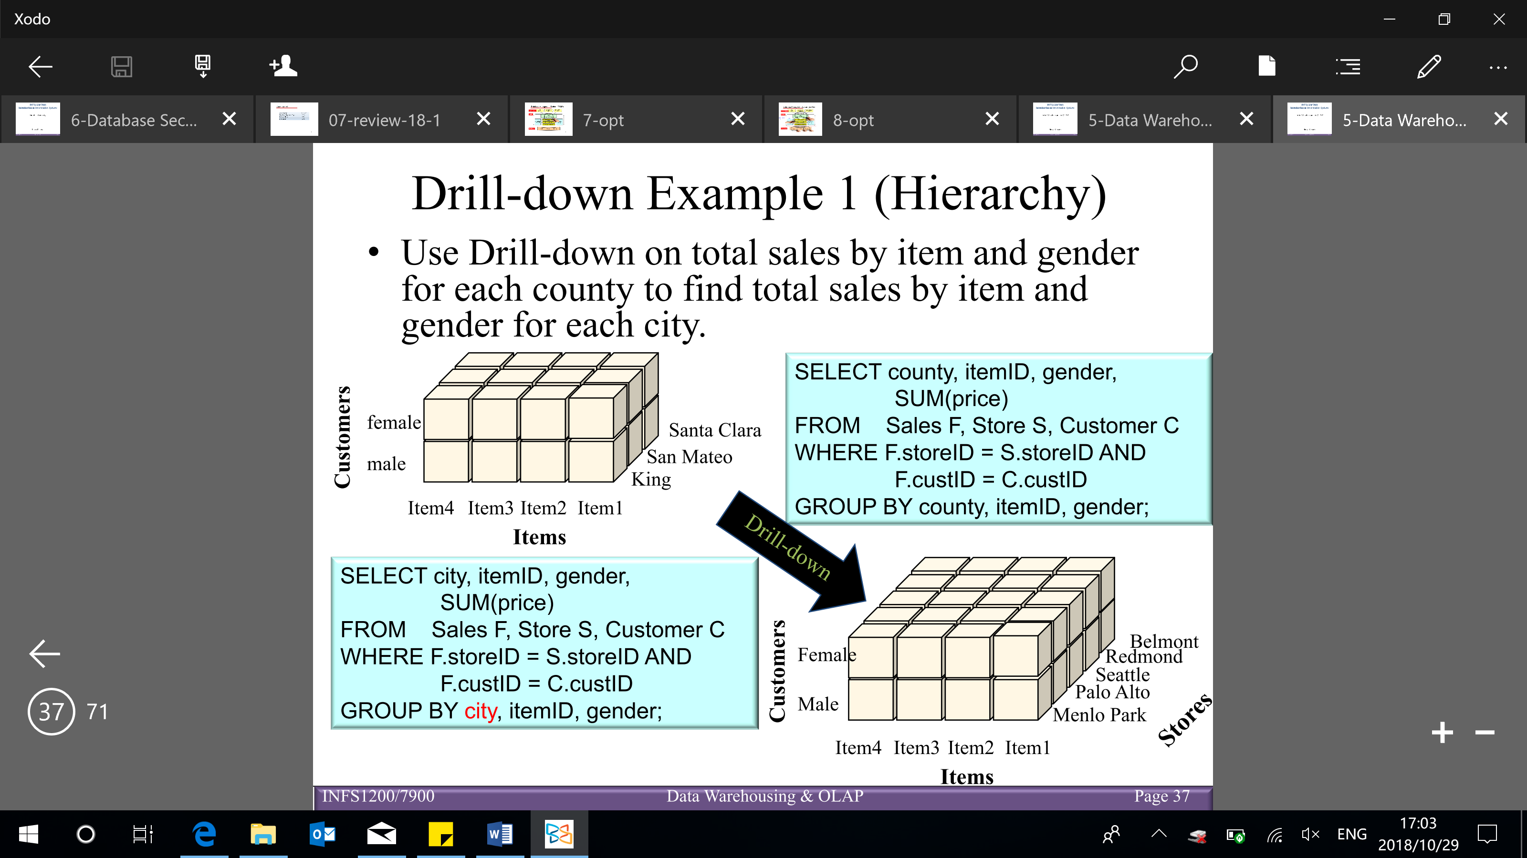

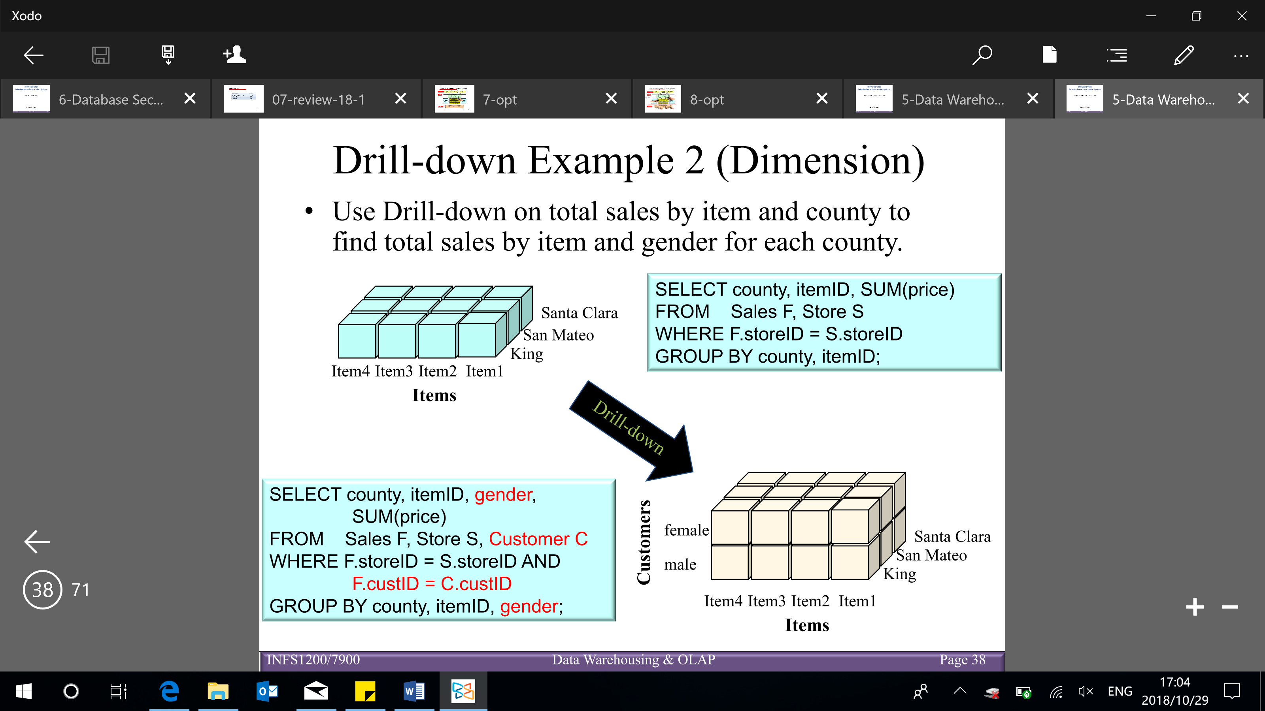

* **Slicing** – produces a slice of the cube by picking a specific value for one of the dimensions (with ‘=’ in WHERE clause)

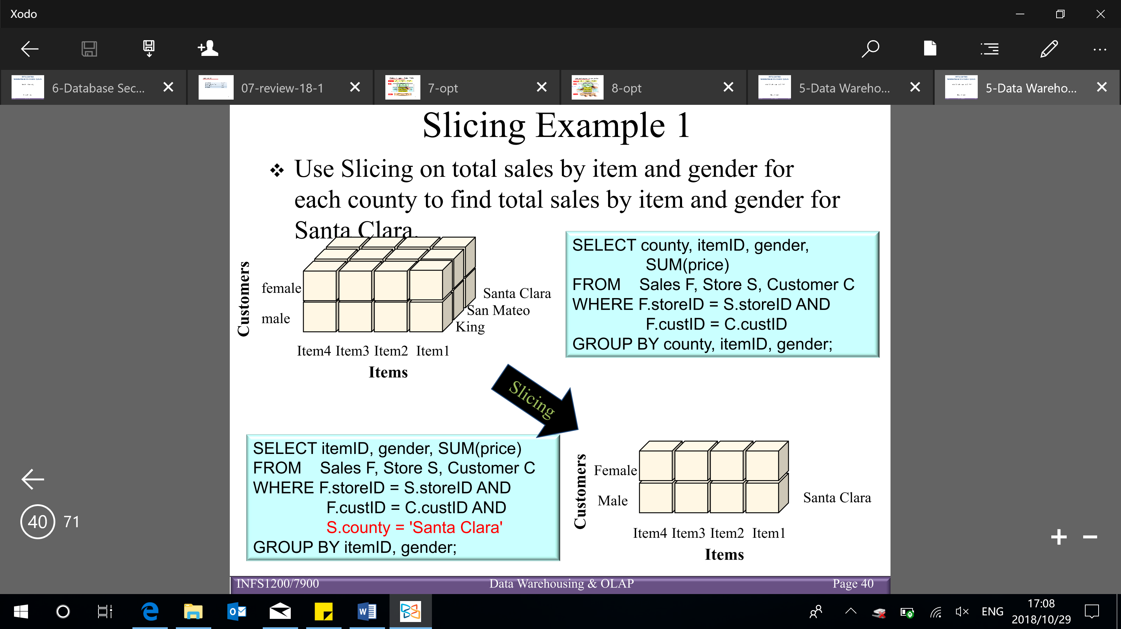

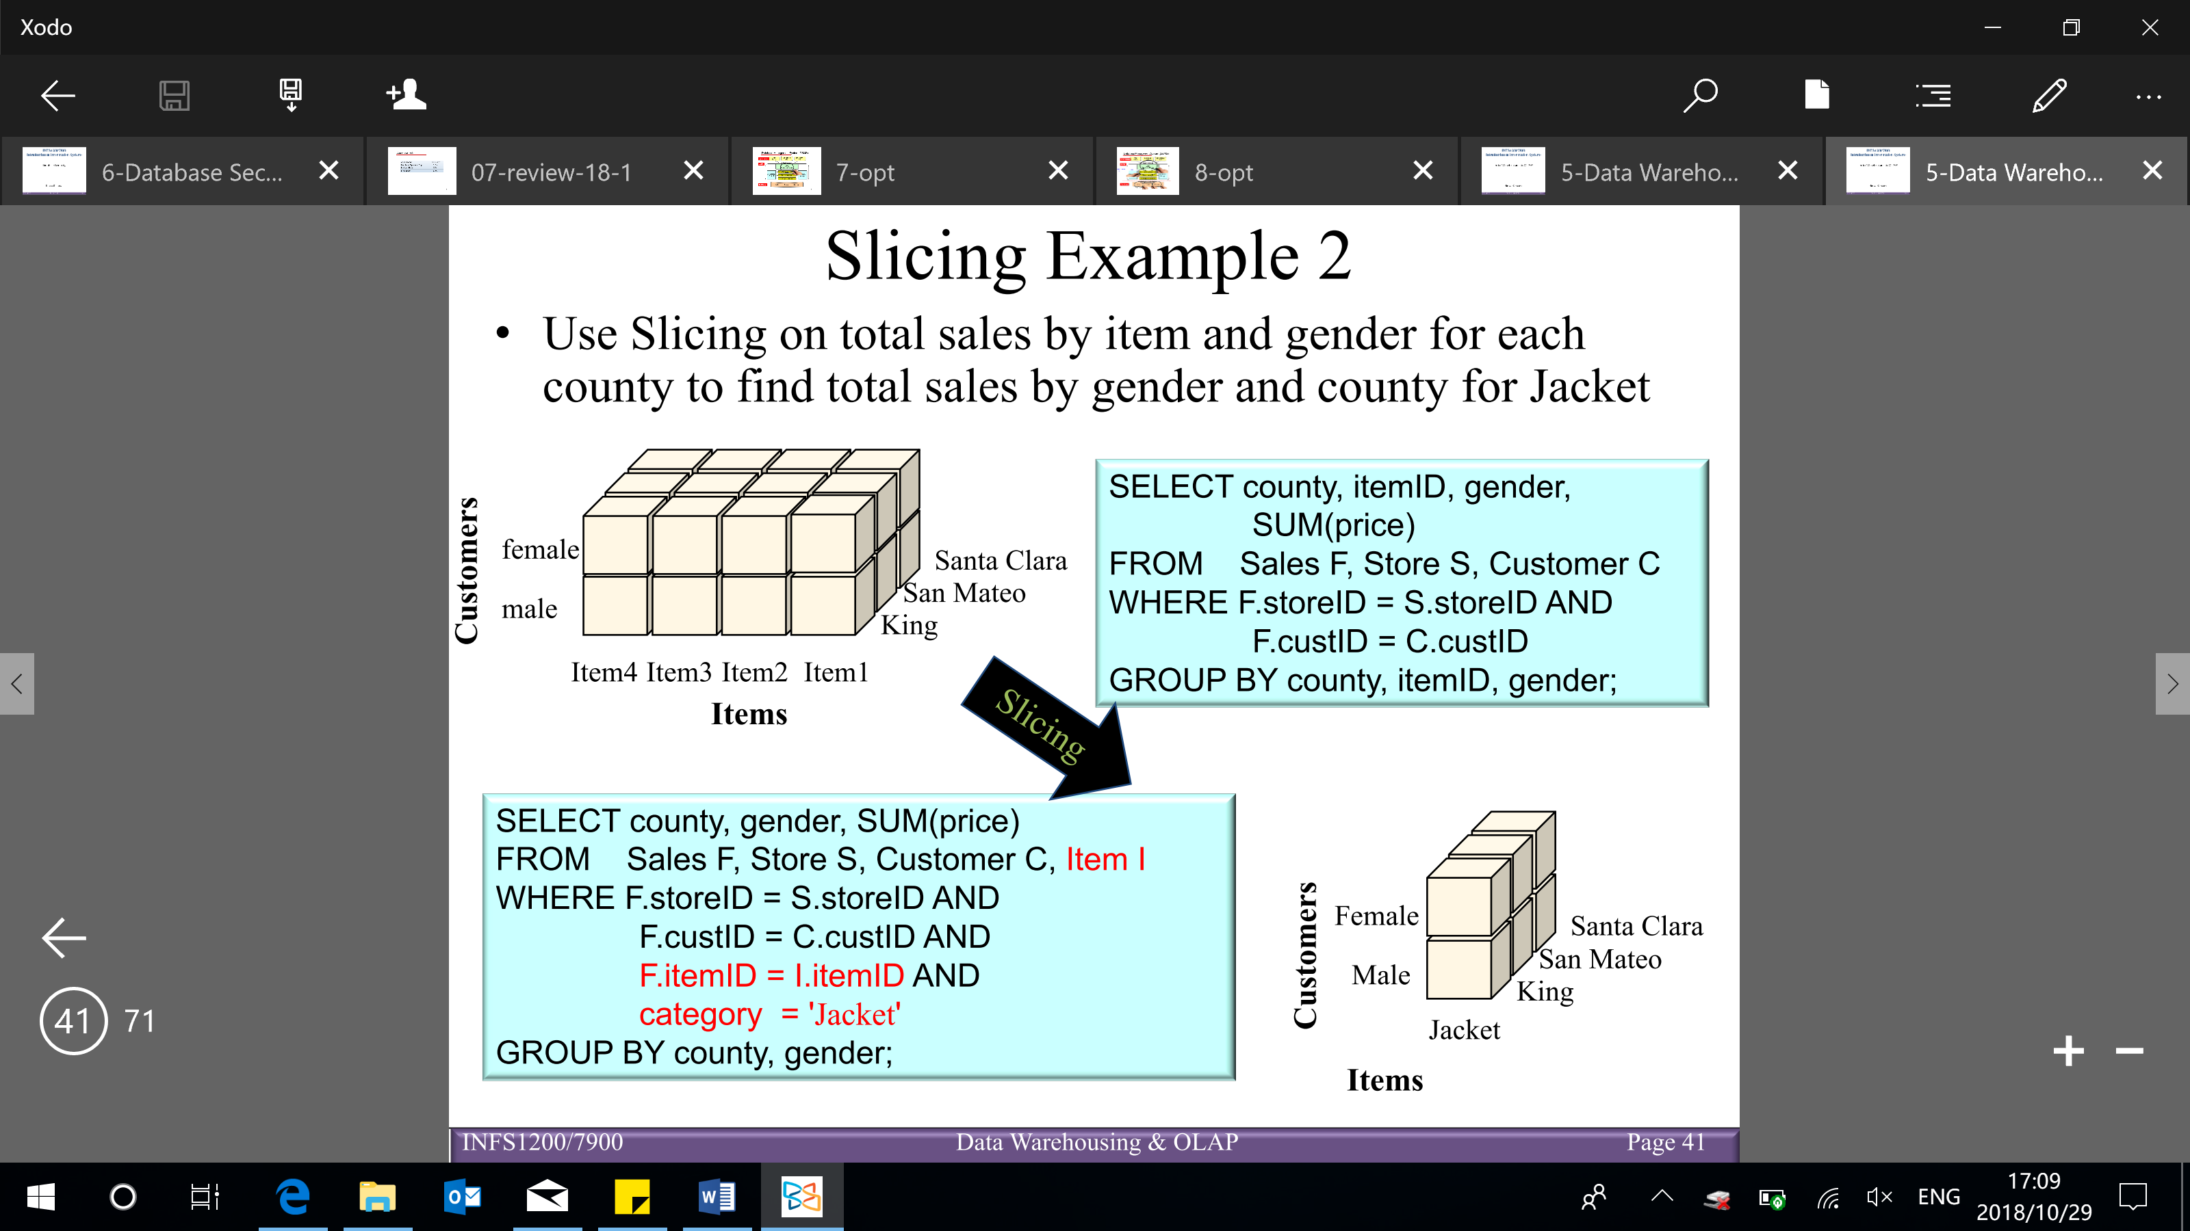

* **Dicing** – produces a sub-cube by picking specific values for multiple dimensions (with ‘=’ in multiple WHERE clause)

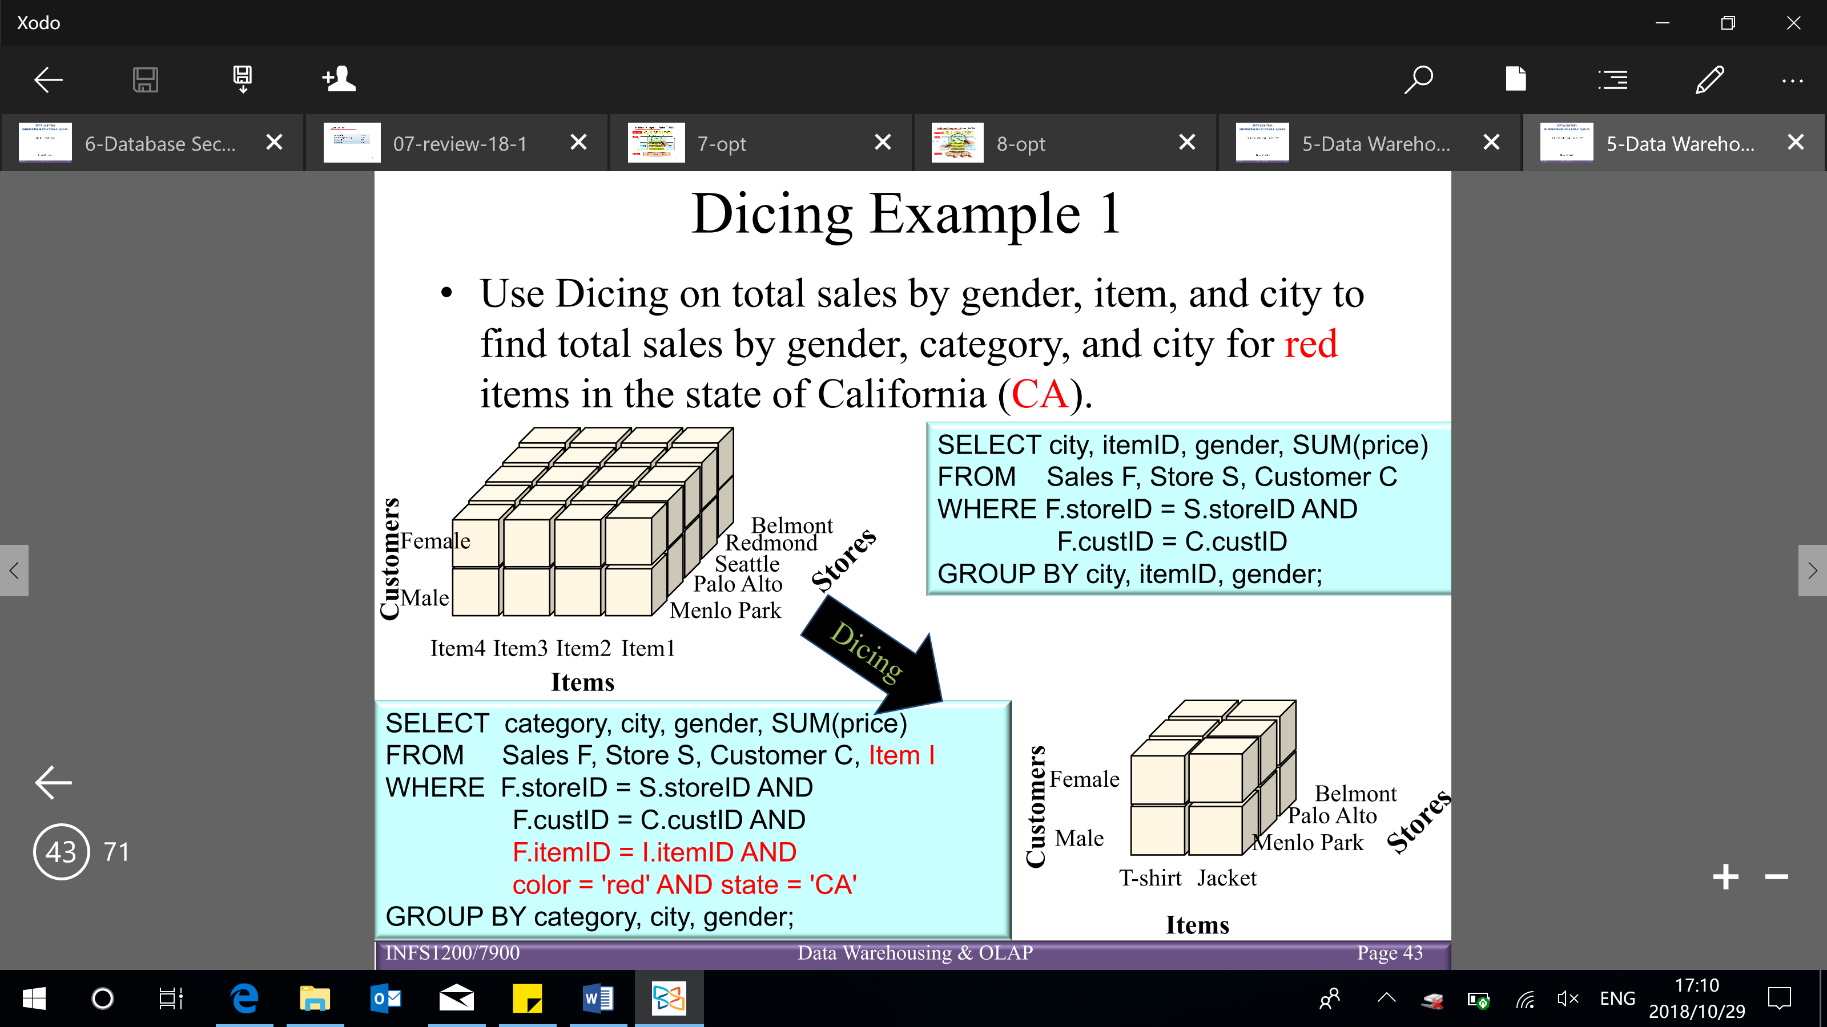

* **Pivoting** – a visualization operation that allows an analyst to rotate the cube in space in order to provide an alternative presentation of the data

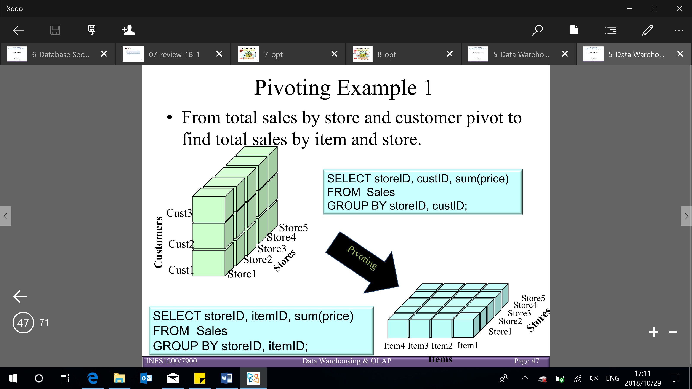

Aggregating over multiple fact tables:

* White (cube) – the cube without any aggregation
* Orange, grey, green (lines) – aggregated over one dimension
* Blue (one value) – aggregated on everything together (all the dimension)

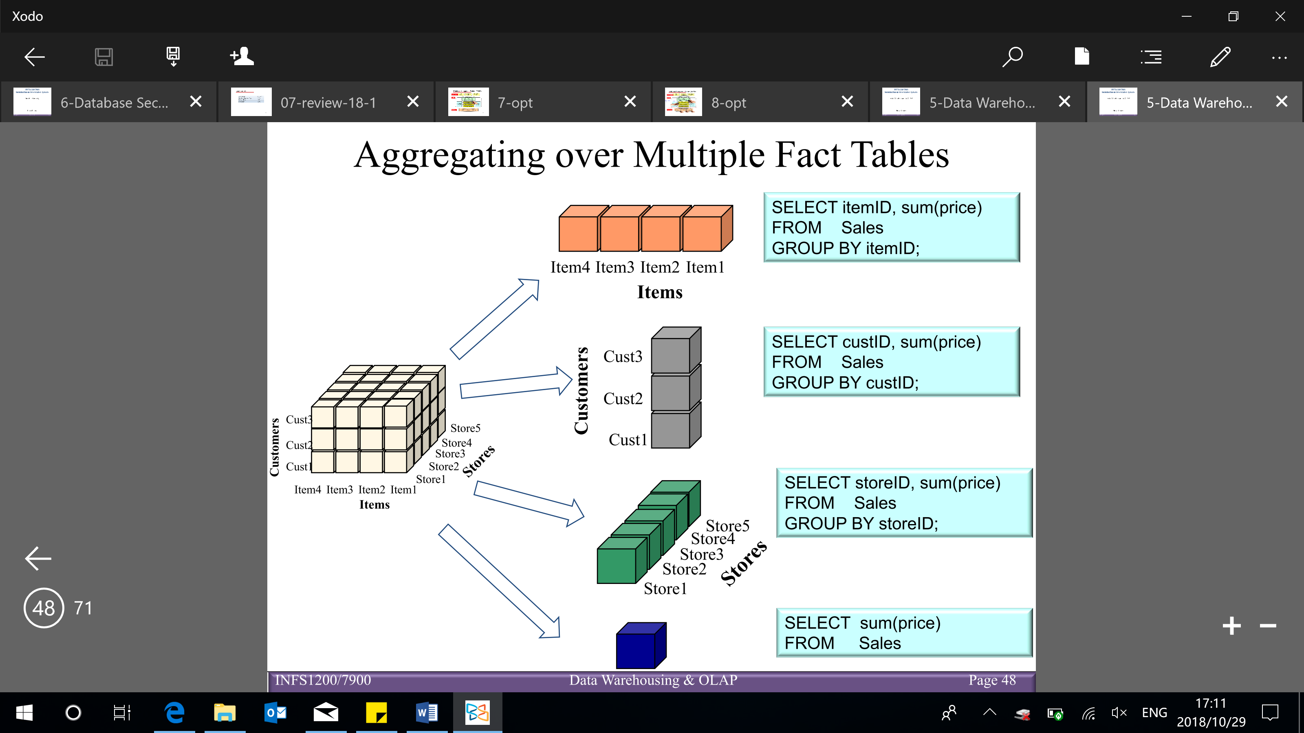

**ROLLUP and CUBE operators**

* Combining fact data and dimensions

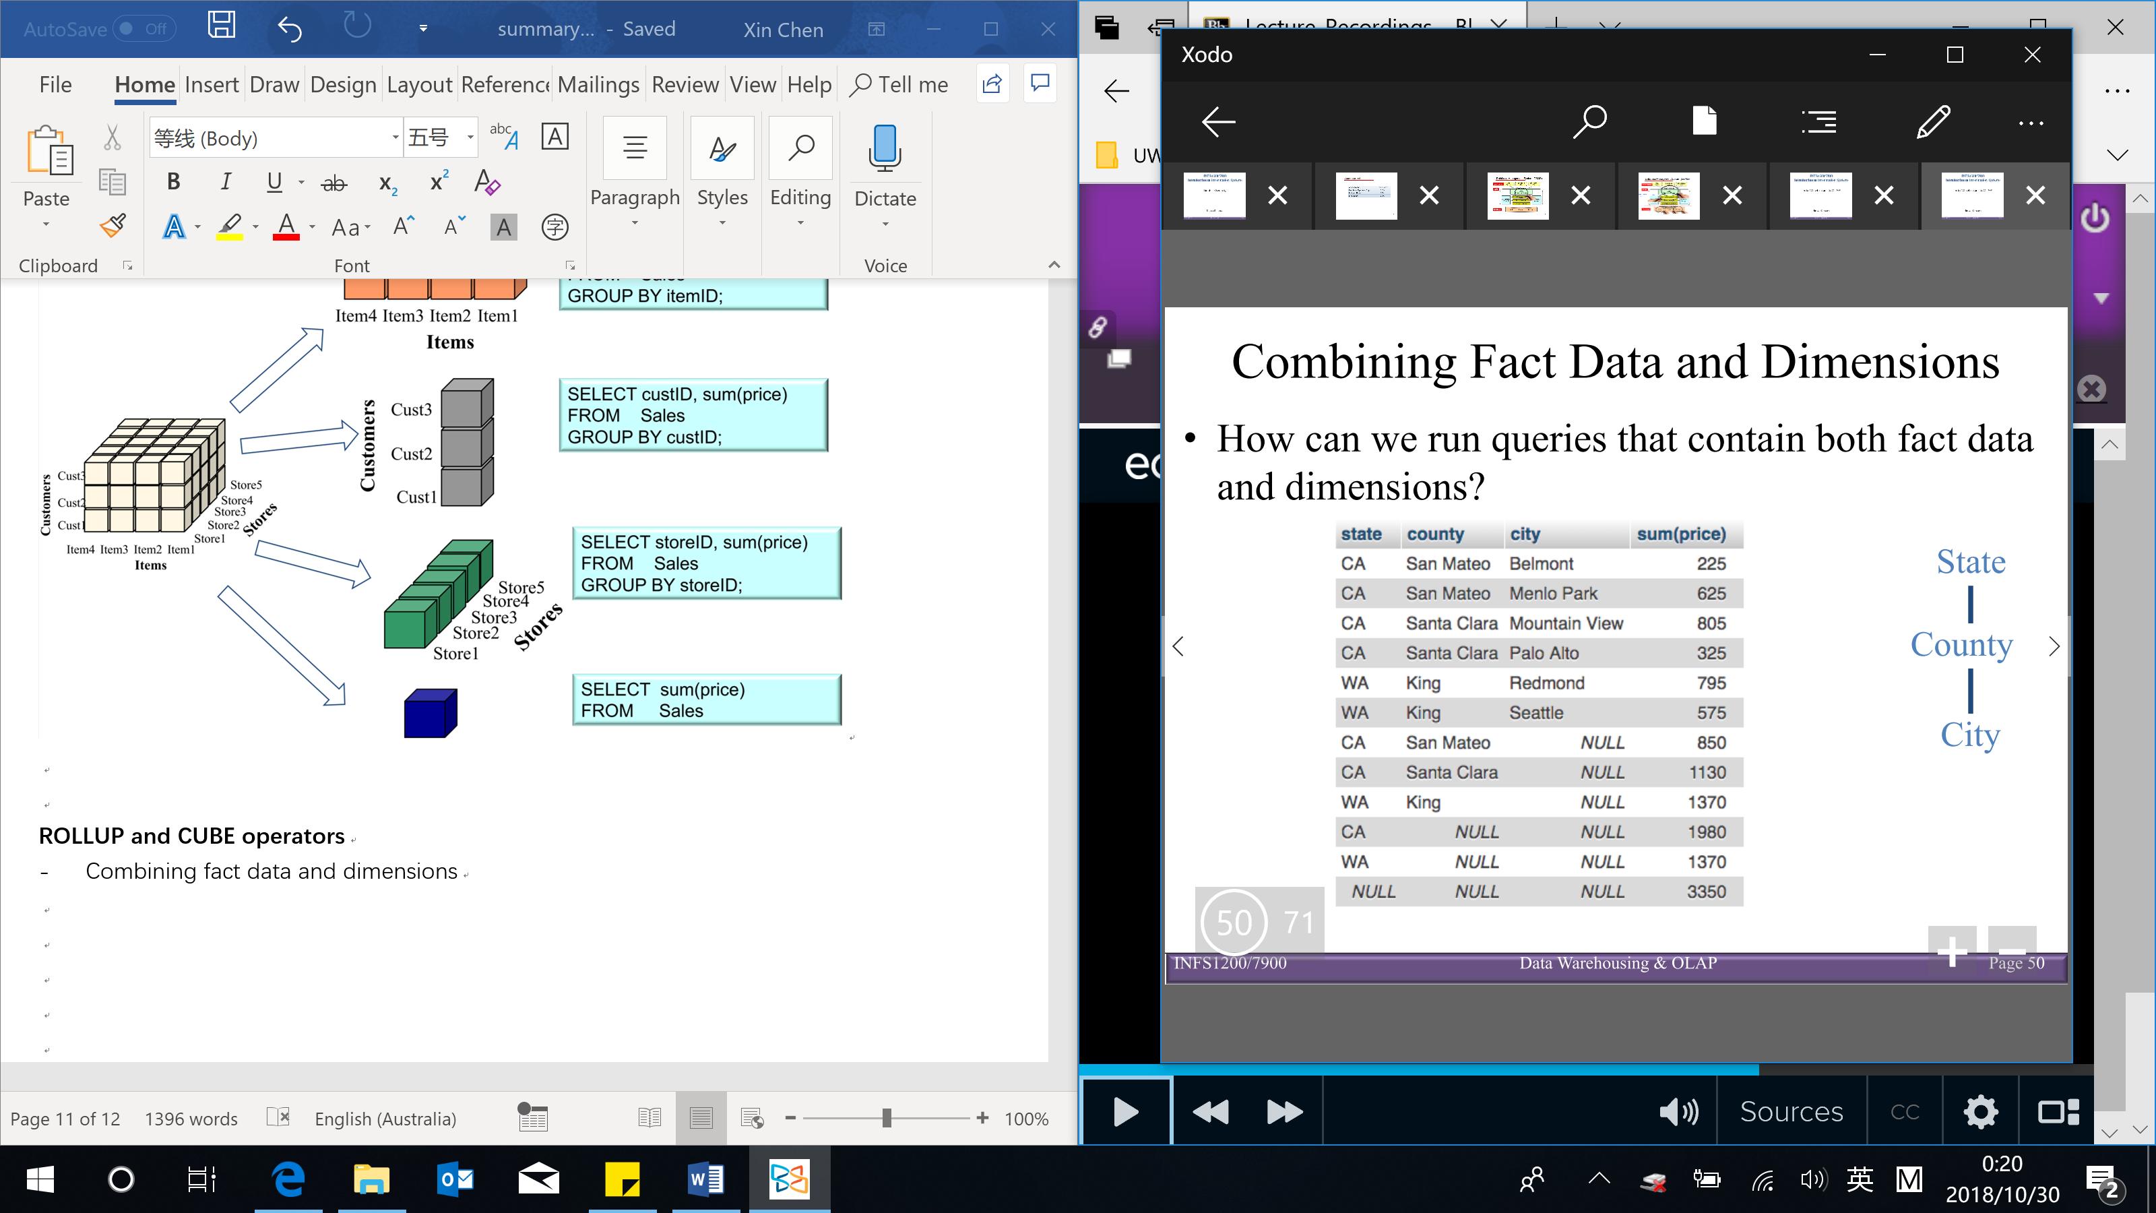

* Using SQL queries

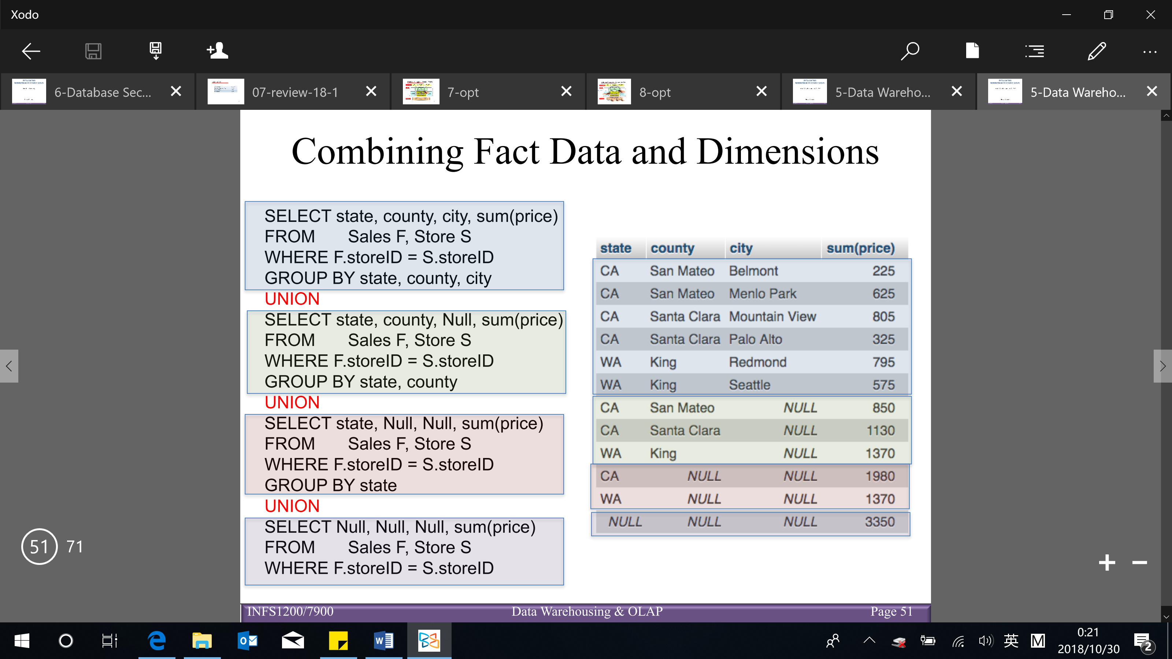

* Using **WITH ROLLUP** at the end of the GROUP BY clause (to get the exactly same result) – get the data across multiple level of the hierarchy

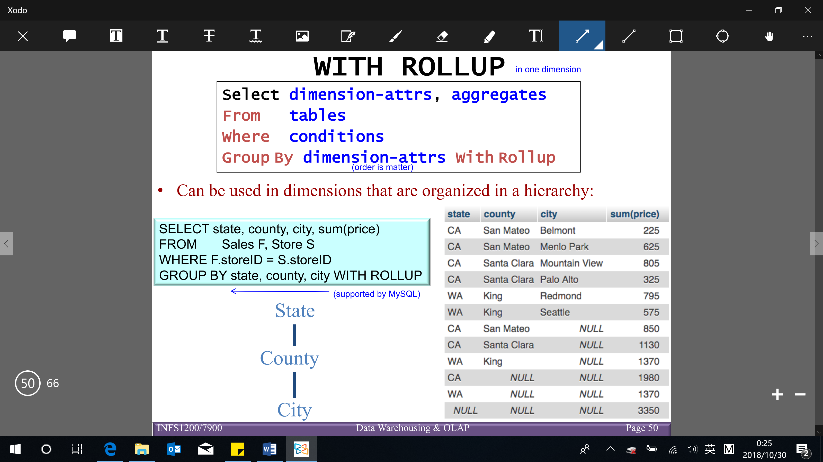

**Data cube** – a k-dimensional object containing both fact data and dimensions

* A cube contains pre-calculated, aggregated, summary information to yield fast queries

White (cube) – data without any aggregation

Orange, green, … (plane) – data aggregated over 2 dimensions

Dark orange, dark green, dark grey (line) – data aggregated over 1 dimension

Blue (dot) – data everything (3 dimensions)

* The small, individual blocks in the multidimensional cube are called cells, and each cell is uniquely identified by the members from each dimension
* The cells contain a measure group, which consists of one or more numeric measures. These are facts (or aggregated facts)

(e.g. example of a measure is the dollar value in sales for a particular product)

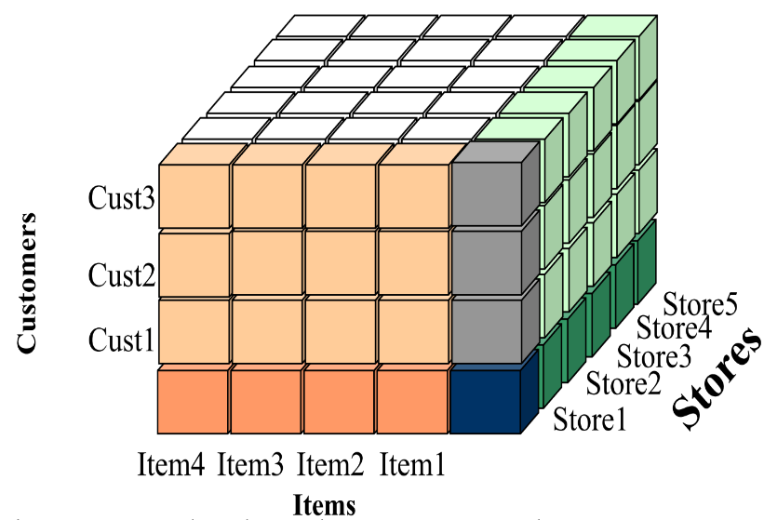

**CUBE** operator (**WITH CUBE** – but it doesn’t support by MySQL)

【Roll-up, drill-down, slicing, dicing, and pivoting operations are expensive】

* Provide efficient computation of multiple granularity aggregates by sharing work (e.g. passes over fact table, previously computed aggregates)
* Number of tuples (result) by running CUBE: $(n+1)(m+1)(k+1)$
* Number of standard SQL queries (through pivoting on a subset of dimensions) are required for computing all of the cells of the cube: $2^{k}$ for a k-dimensional cube

e.g. 3 dimensions $=2^{3}=8 OR=1+3+3+1=8$

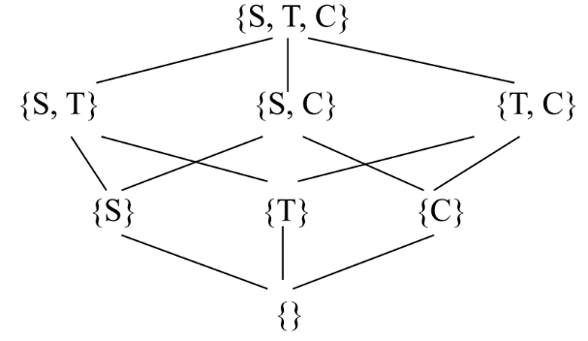

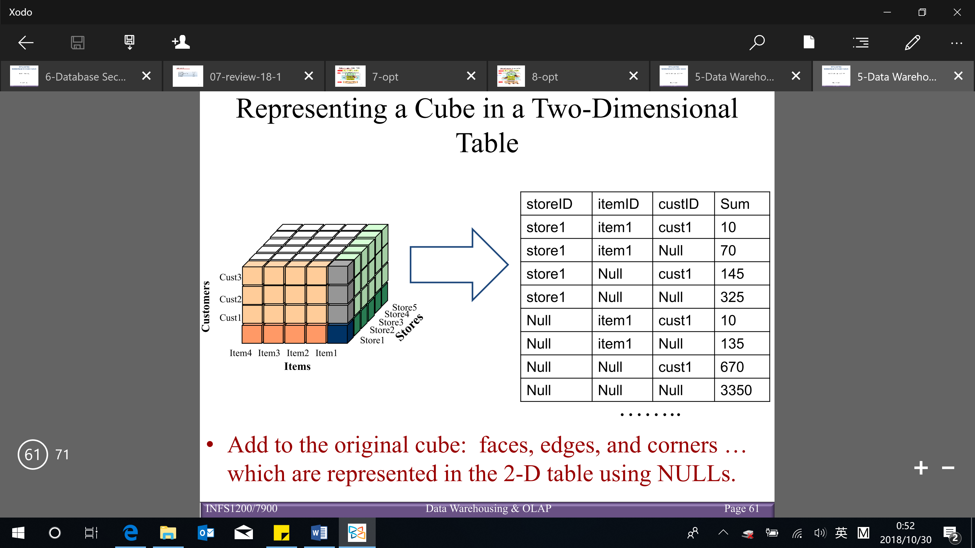

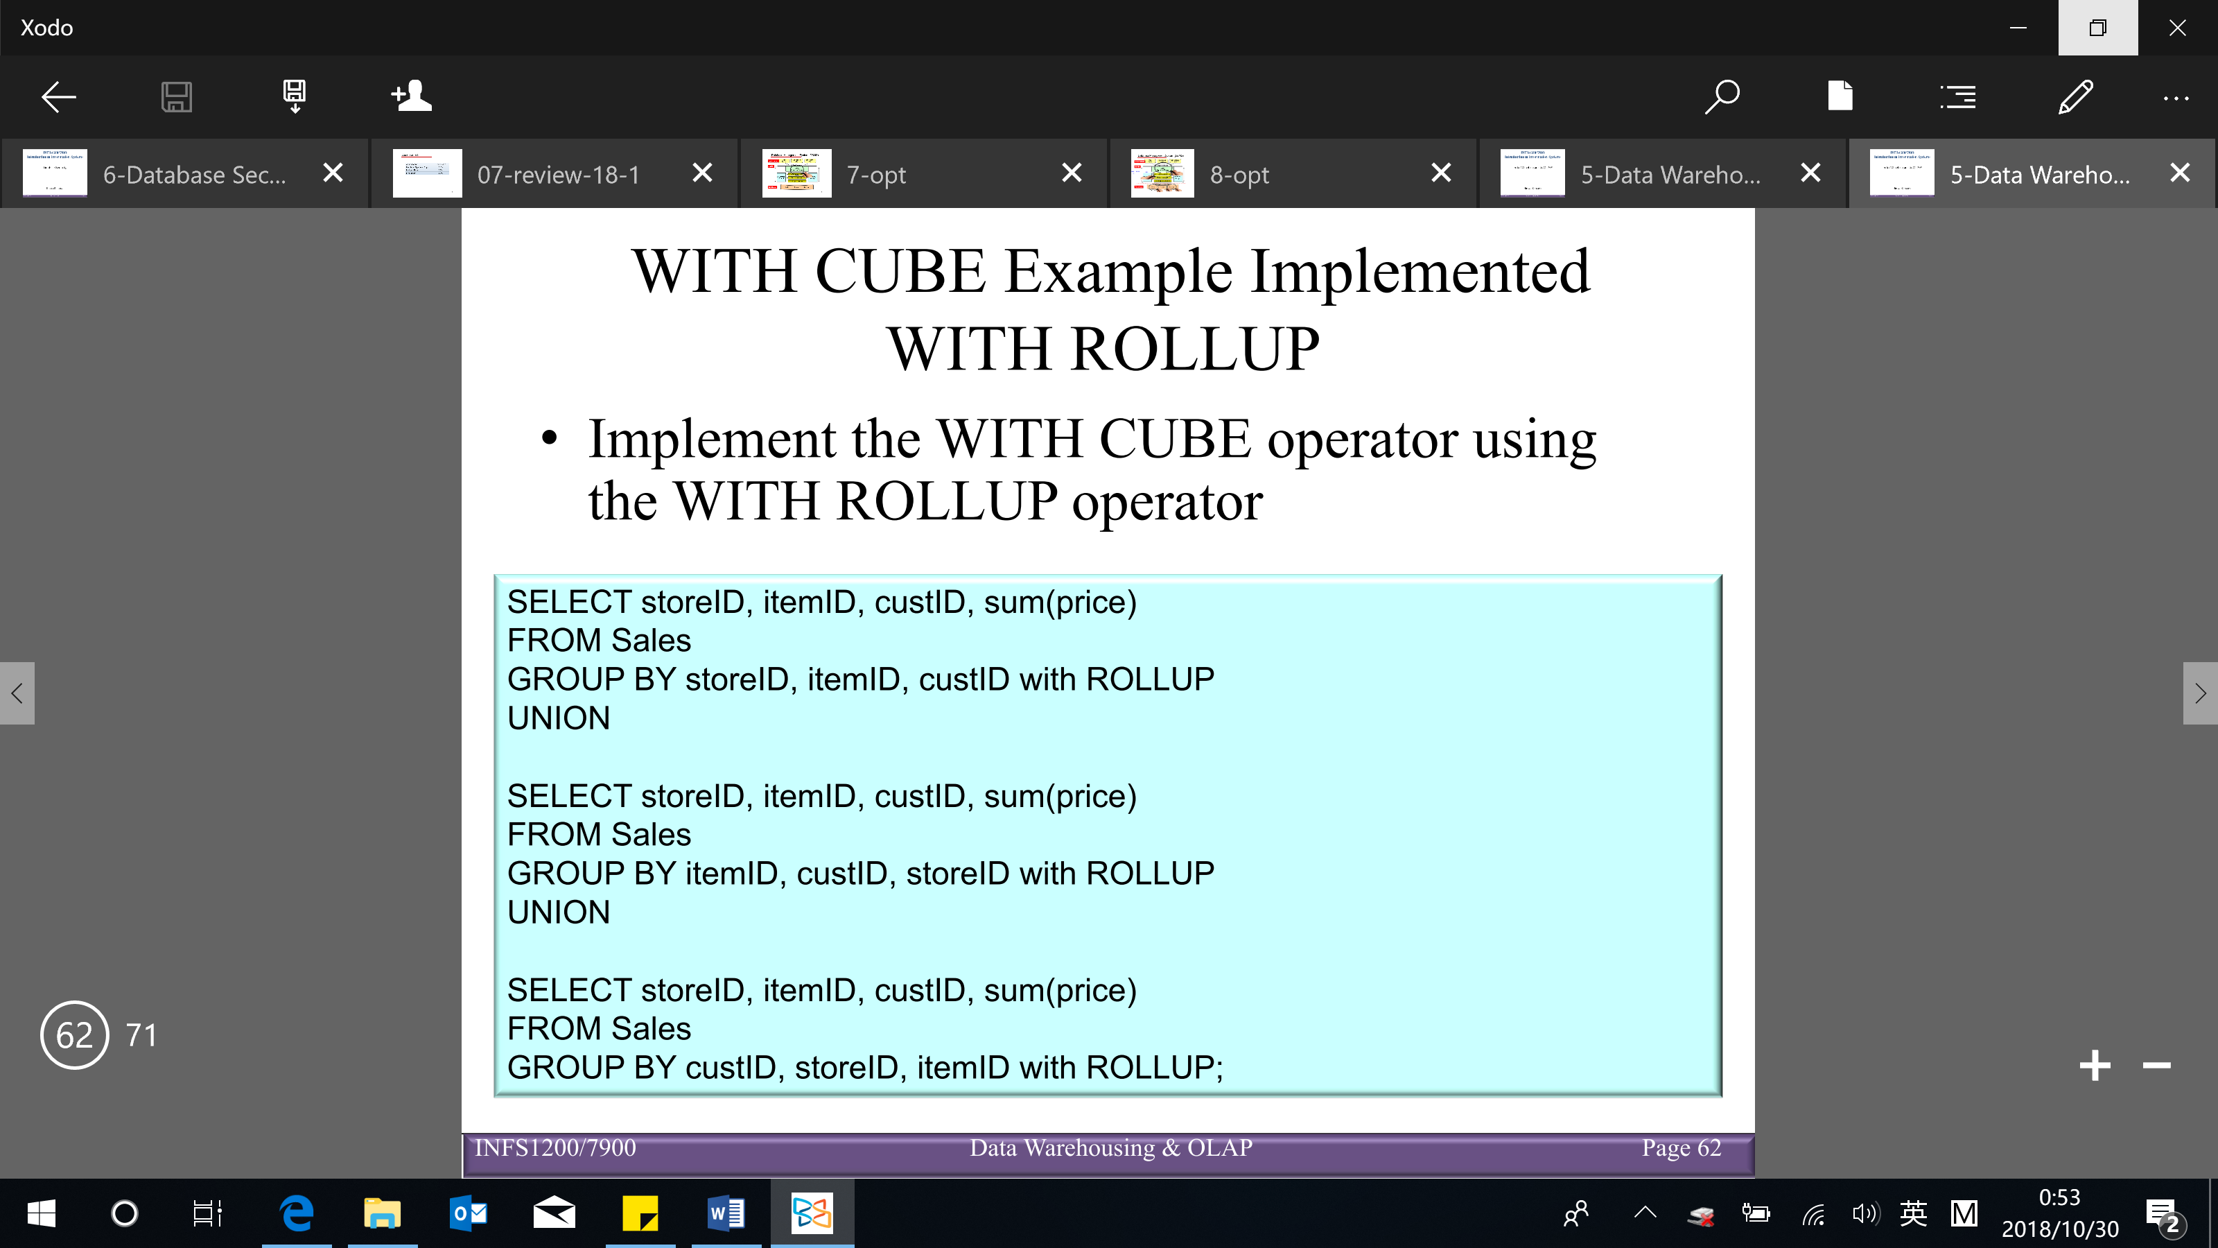

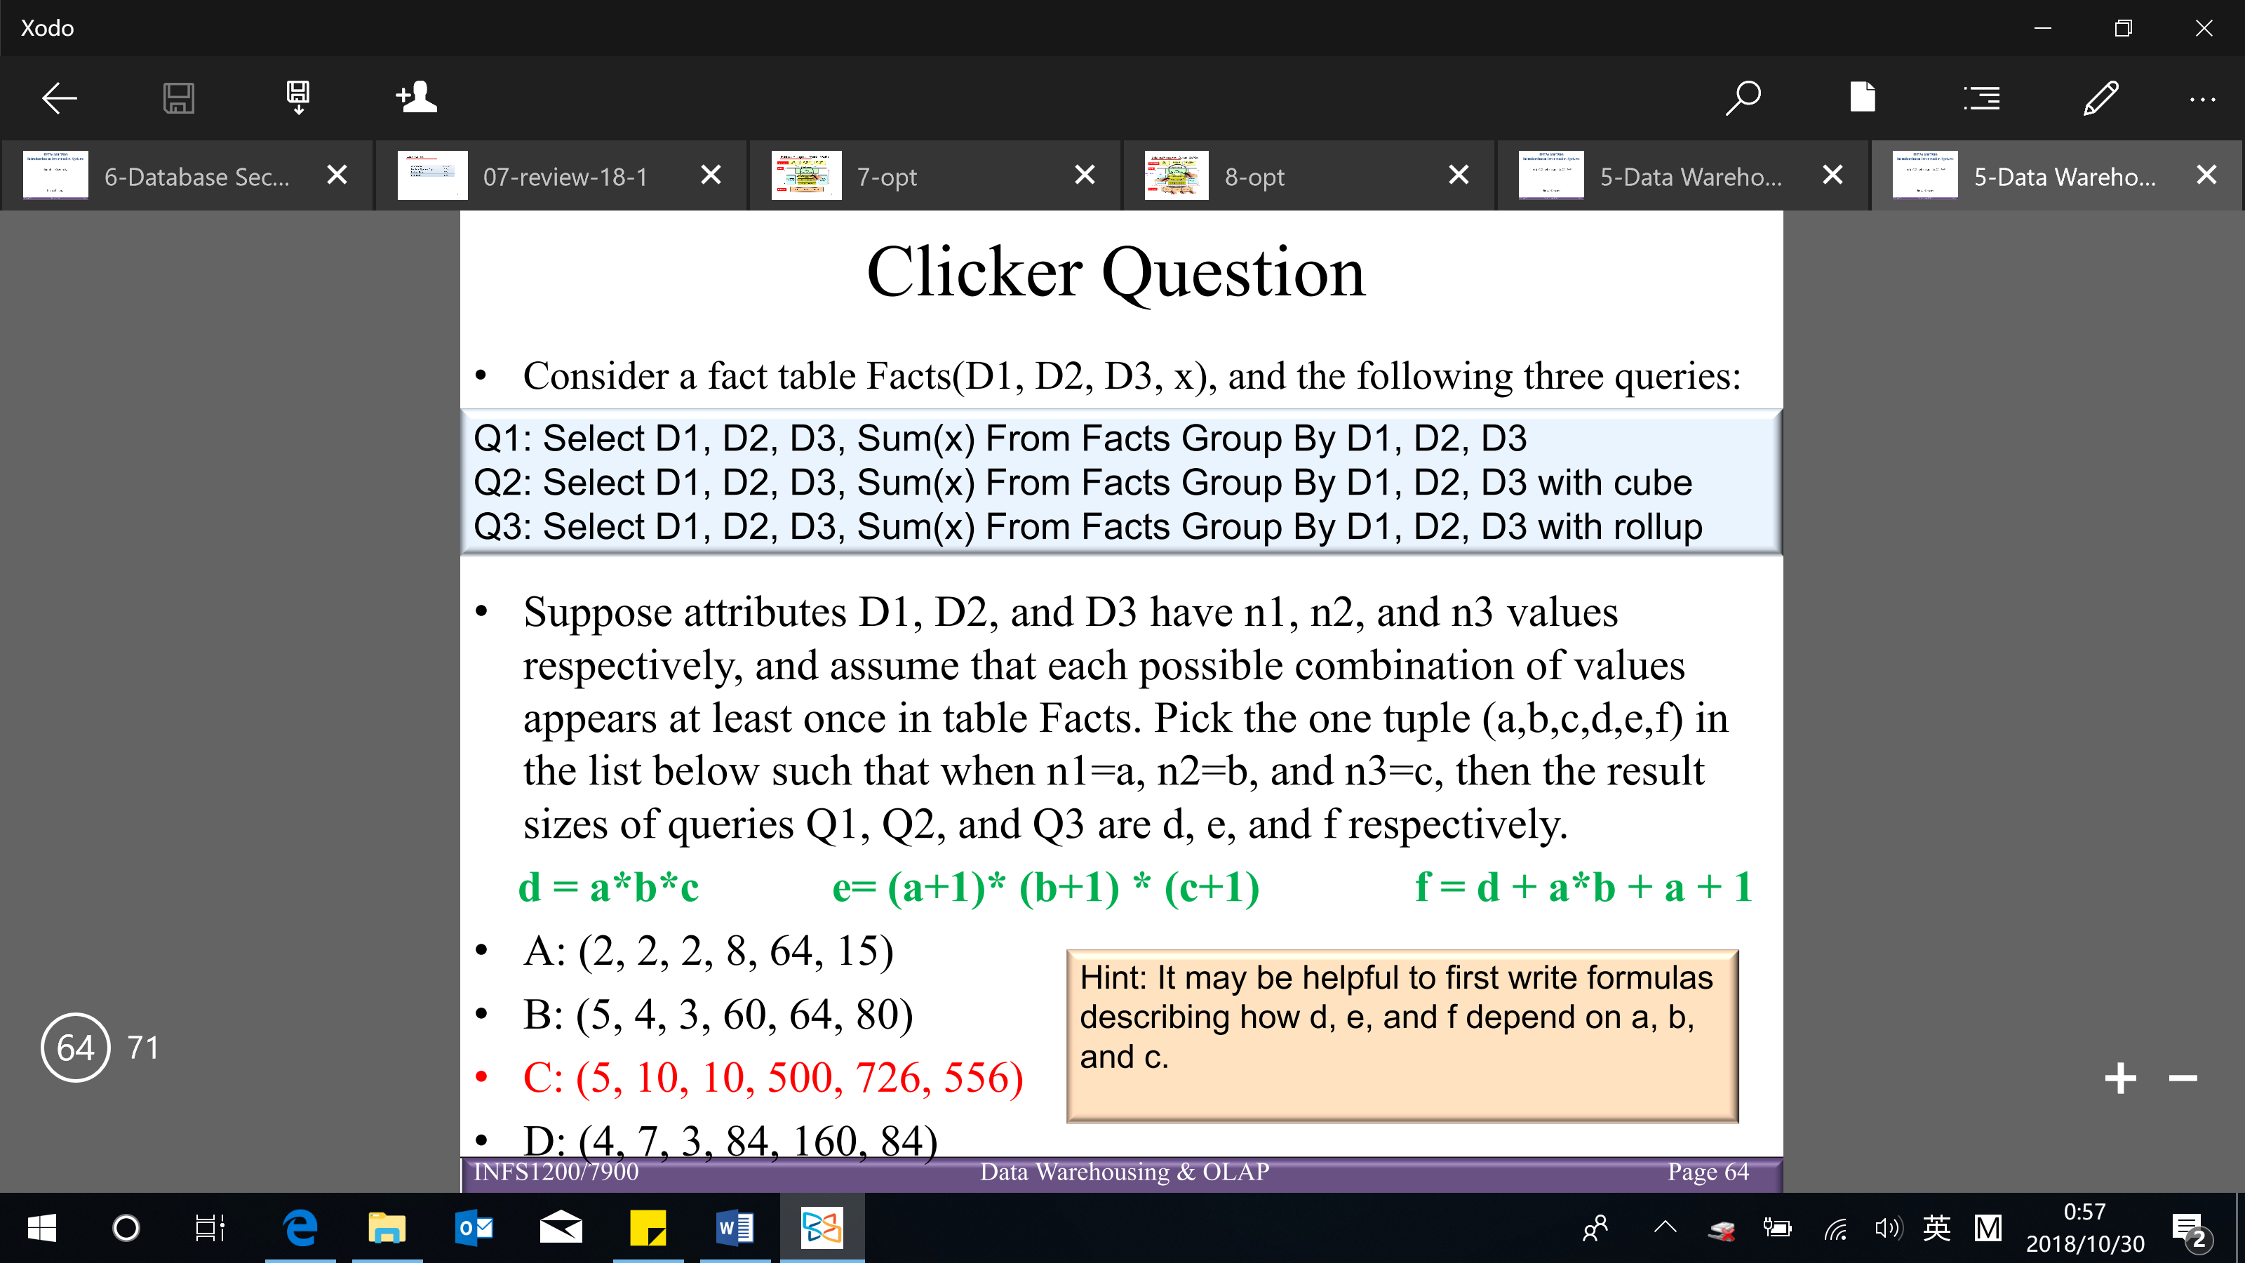

**Star schema V.S. snowflake schema**

* Star schema (details above) [very common in OLAP applications]

One table for the fact table (in BCNF)

One table per dimension (not normalized)

* Snowflake schema

Each dimension is normalized into a set of tables

Usually, one table per level of hierarchy per dimension

Query formulation is inherently more complex (more join)

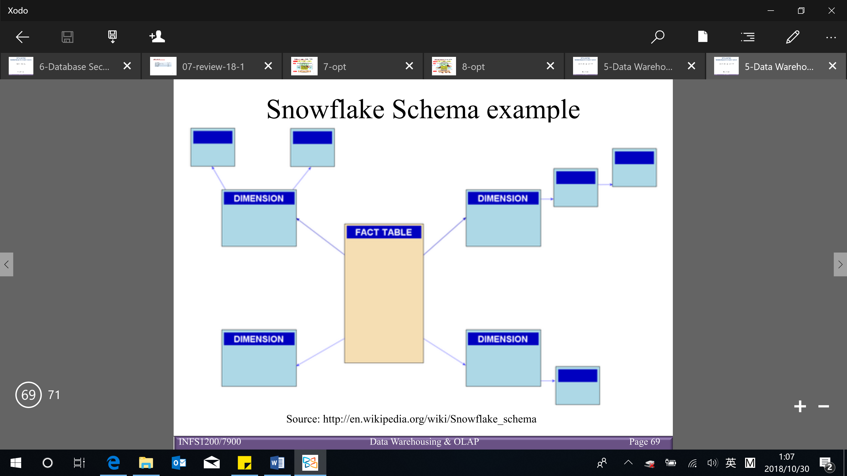

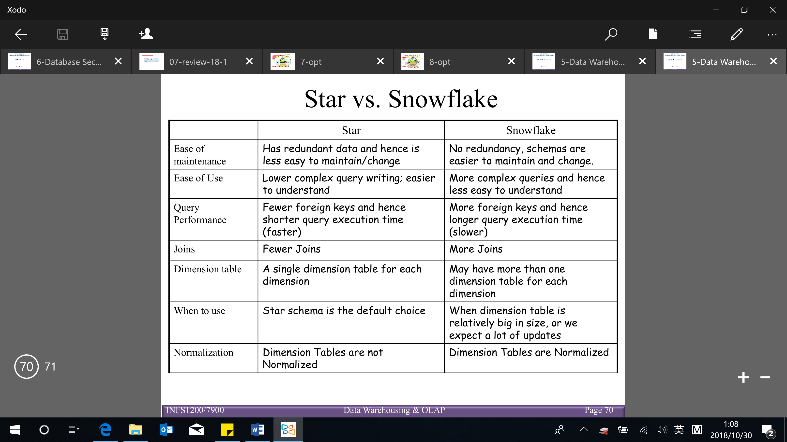

**Database security**

Intro to database security issues

Sensitive data – information that is protected against unwarranted disclosure

Types of sensitive data:

* Inherently sensitive (e.g. patient data)
* From a sensitive source
* Declared sensitive
* A sensitive attribute or sensitive record
* Sensitivity in relation to previously disclosed data (e.g. data in one database is sensitive to the data in another database)

Privacy is important

→ misusing sensitive data

e.g. patient data (inherently sensitive) – health insurance, advertising, identity theft, etc

people behaviour/ social habit (not inherently sensitive) – stalking, blackmail, advertising, kidnapping, tracking, crime, etc

**Privacy**: ability of individuals to control the terms under which their sensitive data (personal information) is acquired and used

**Security**: a required building block for privacy, which includes:

* Preventing storage of sensitive data
* Ensuring appropriate/ authorized (access of people) use of sensitive data

Why database security:

* Legal or policy reasons

e.g. Privacy Act of Australia intends to protect privacy of individuals’ data, such as, medical, financial rating, etc

* Ethical reasons

e.g. accessing employee salary packages, student grades, …

* Technical reasons

e.g. protect from malware (any program or file that is harmful to a computer user, includes computer viruses, worms, Trojan horses and spyware), performance overload, …

Threats to database security (CIA)

* Loss of confidentiality: unauthorized disclosure of confidential information
* Loss of integrity: improper modification of information
* Loss of availability: legitimate user cannot access data objects

Database control measures:

1. Access control – handled by creating user accounts and passwords (and give different privilege to these accounts)
2. Inference control – must ensure information about individuals cannot accessed
3. Flow control – prevents information from flowing to unauthorized users (avoid the situation that more privilege people can provide the flow of moving that data over for less privilege users to see and interact with)
4. Data encryption – used to protect sensitive transmitted data (protect data while it’s in transaction)

[1 – details below, 2,3,4 – details at the end]

Basic DBMS security functions

* User accounts: user must log in using assigned username and password
* Login session: sequence of database operations by a certain user recorded in system log (log store the information on the users)
* Database audit: reviewing log to examine all accesses and operations applied during a certain time period

Log in audit can use to see who made a change that they won’t meant to make

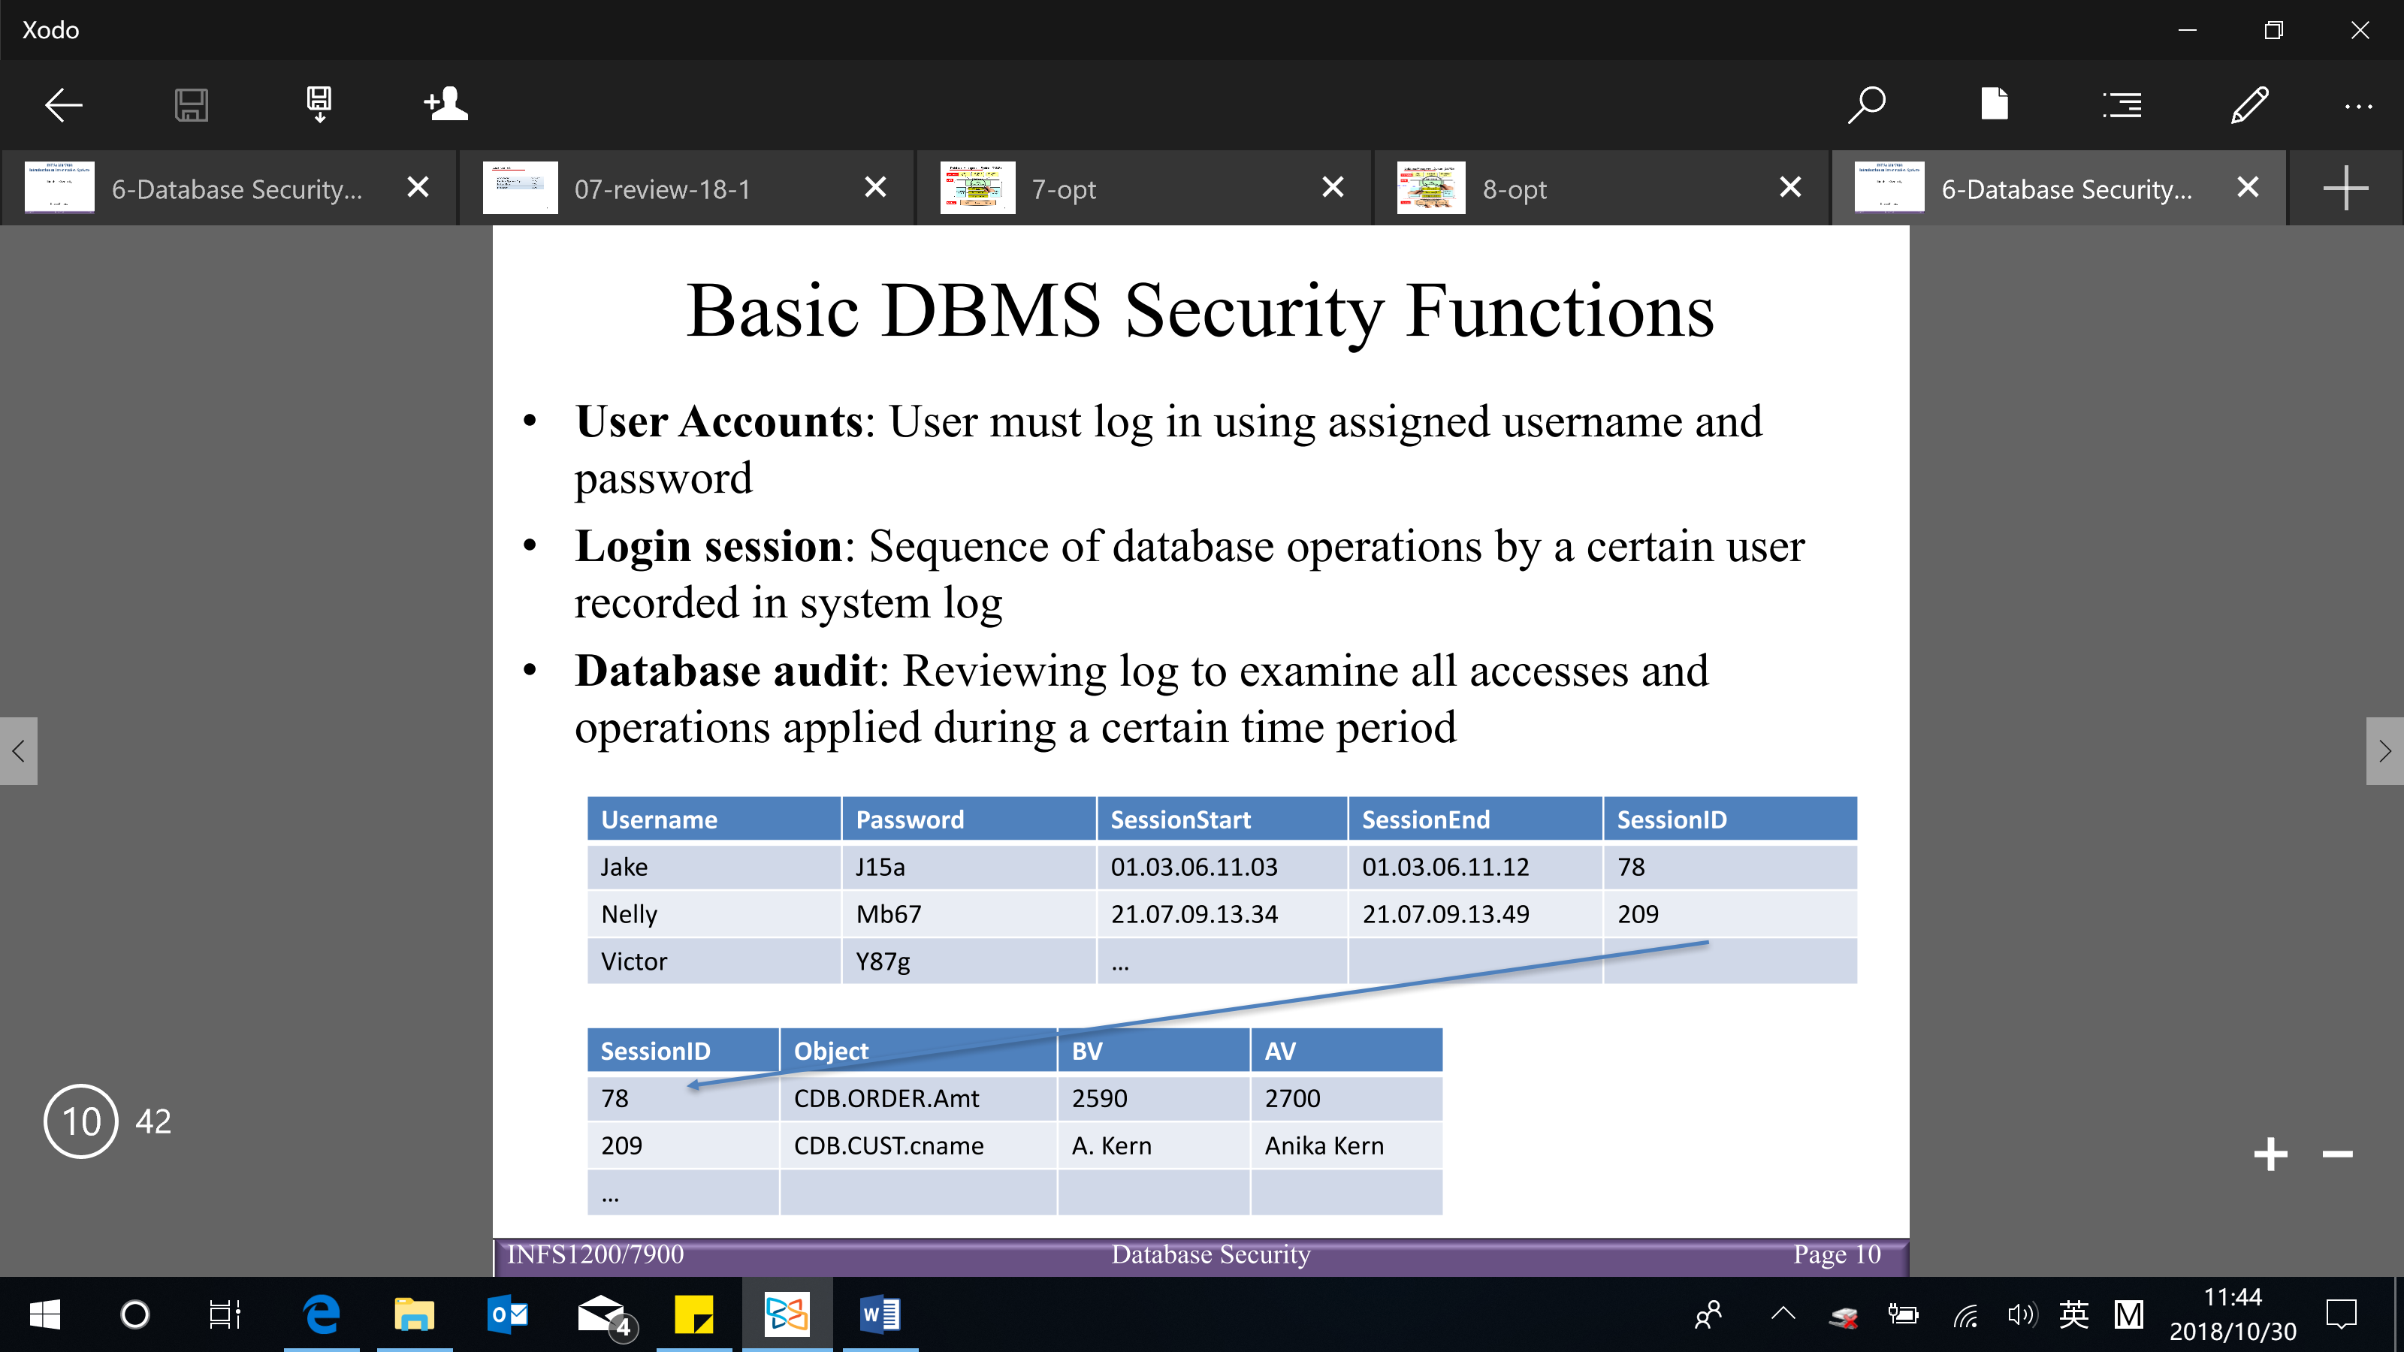

**Access control mechanisms** (3 ways):

* Discretionary access control: used to grant privileges to users

2 levels for assigning privileges to use a database system

* Account level (high level)

e.g. CREATE SCHEMA or CREATE TABLE privilege

* Relation/table level

Access matrix model

1. Each relation R assigned an owner account
2. Owner can grant (select/read, modification/write and references) privileges to other users on any owned relation

[When one of the users want to run a query, first step is checking the access matrix to see whether that user have the privilege to run that query or not]

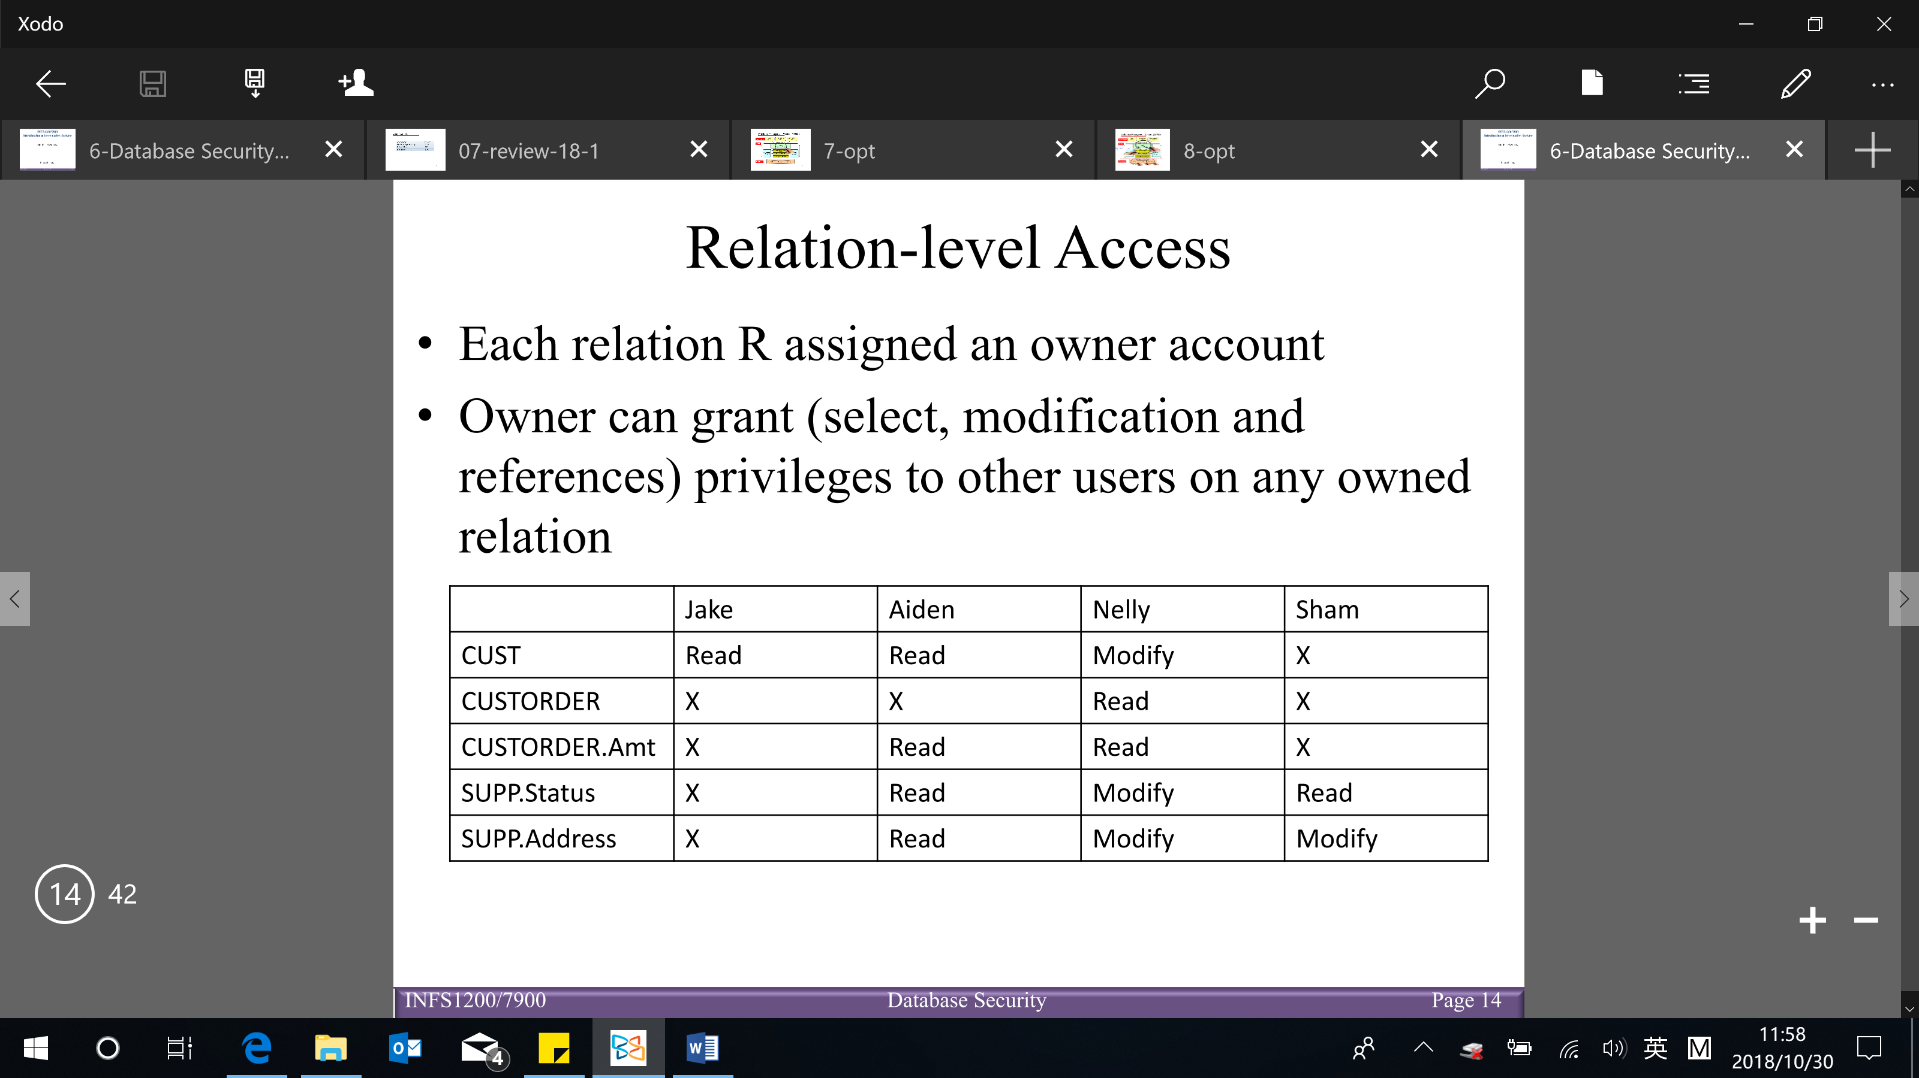

Syntax use to specify the privilege (SQL):

* Specifying privilege through views

Grant privilege:

Consider owner A of relation R and other party B

A can create view V of R that includes only attributes and tuples that A wants B to access

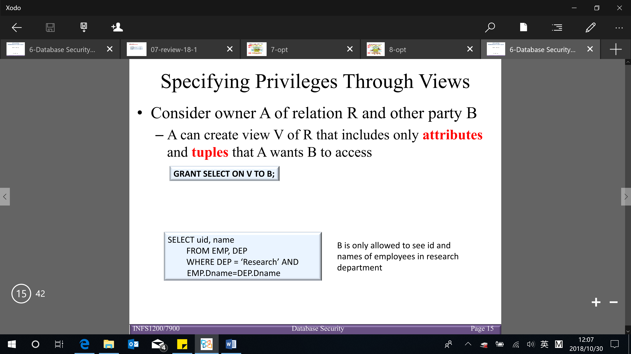 (SELECT – read access)



Revoking of privileges:

REVOKE command used to cancel a privilege

Useful for granting a privilege temporarily

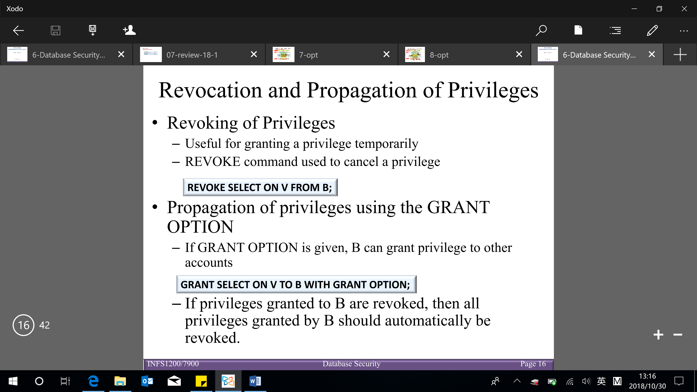

Propagation of privileges using the GRANT OPTION:

If GRANT OPTION is given, B can grant privilege to other account

If privileges granted by B are revoked, then all privileges granted by B should automatically be revoked



(a user has an authorization if and only if there is a path from the root of the authorization graph down to the node representing the user)

* Mandatory access control: classify data and users into various security classes (TS, S, C, U) & implement security policy on top of different classes (who can read or write what)

Additional security policy that classifies data and users based on security classes

Typical security classes (4):

* Top secret (TS)
* Secret (S)
* Confidential (C)
* Unclassified (U)

Bell-LaPadula model is commonly used – subject and object classifications (which subject can access which object)

* Simple security property (intuitive)

Subject S not allowed read access to object O unless $class\left(S\right)≥class\left(O\right)$

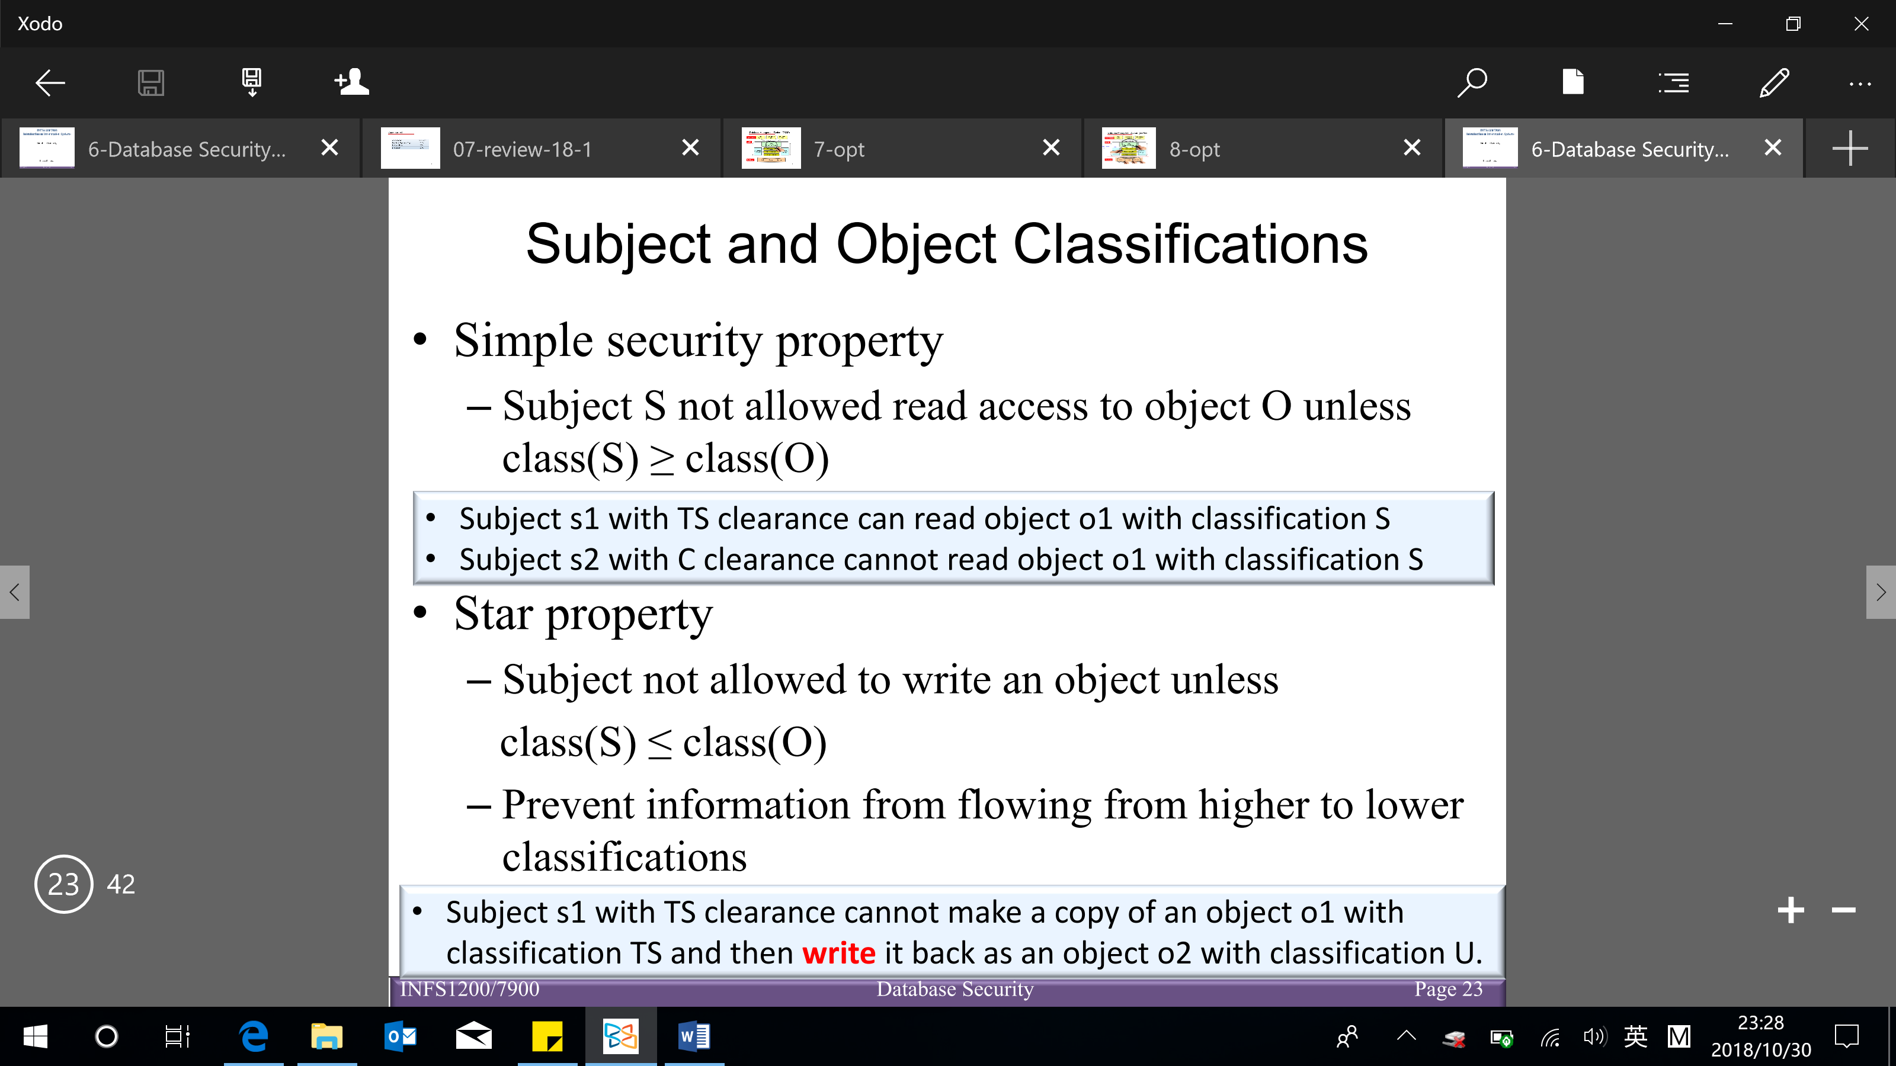

* Star property

Subject not allowed to write an object unless $class\left(S\right)≤class(O)$ (can only write the things higher or equal to its class)

Prevent information from flowing from higher to lower classification



【Mandatory access control ensure a high degree of protection and prevents illegal flow of information. However they are too rigid in that they require a strict classification of objects and subjects】- not very often used in application

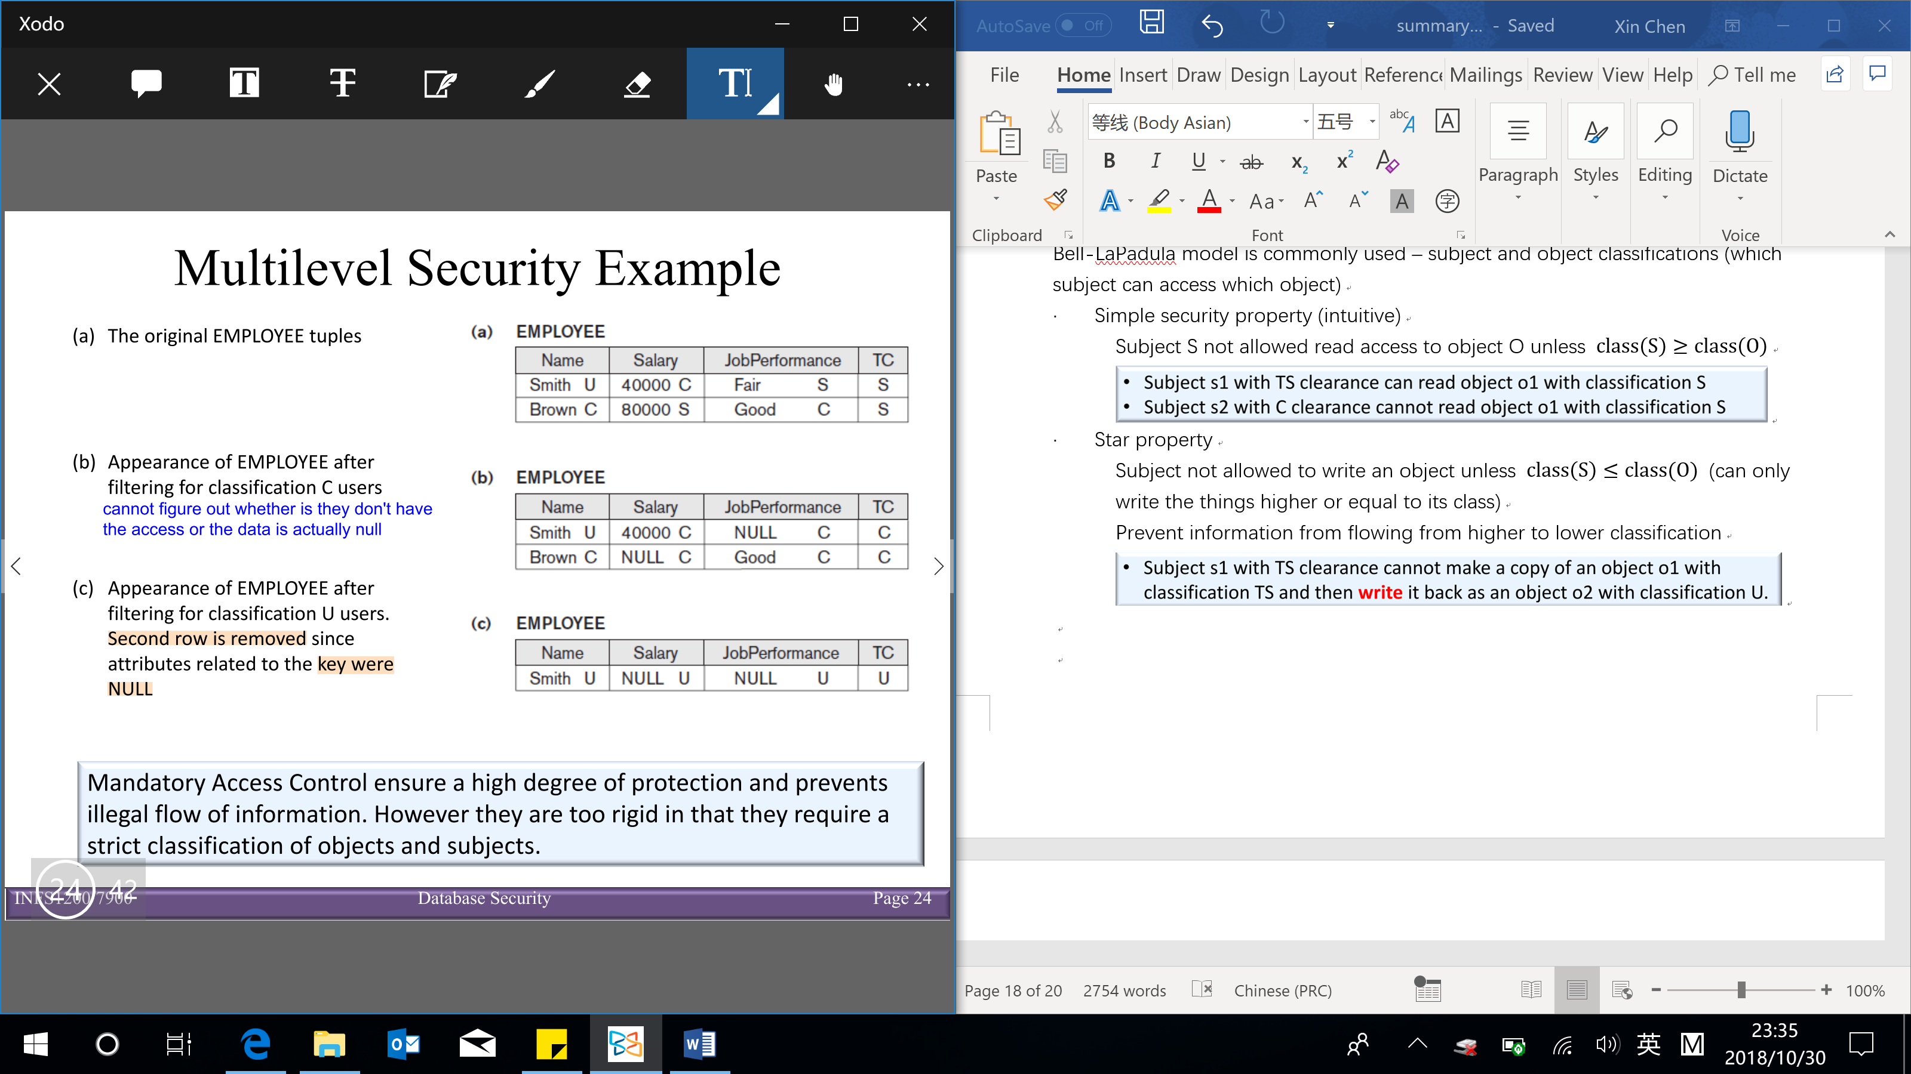

* Role-based access control (not in user-level)

Privileges are associated based on organizational roles (define user types/roles) rather than individual users → users are assigned to appropriate roles

Can be used with traditional discretionary and mandatory access control

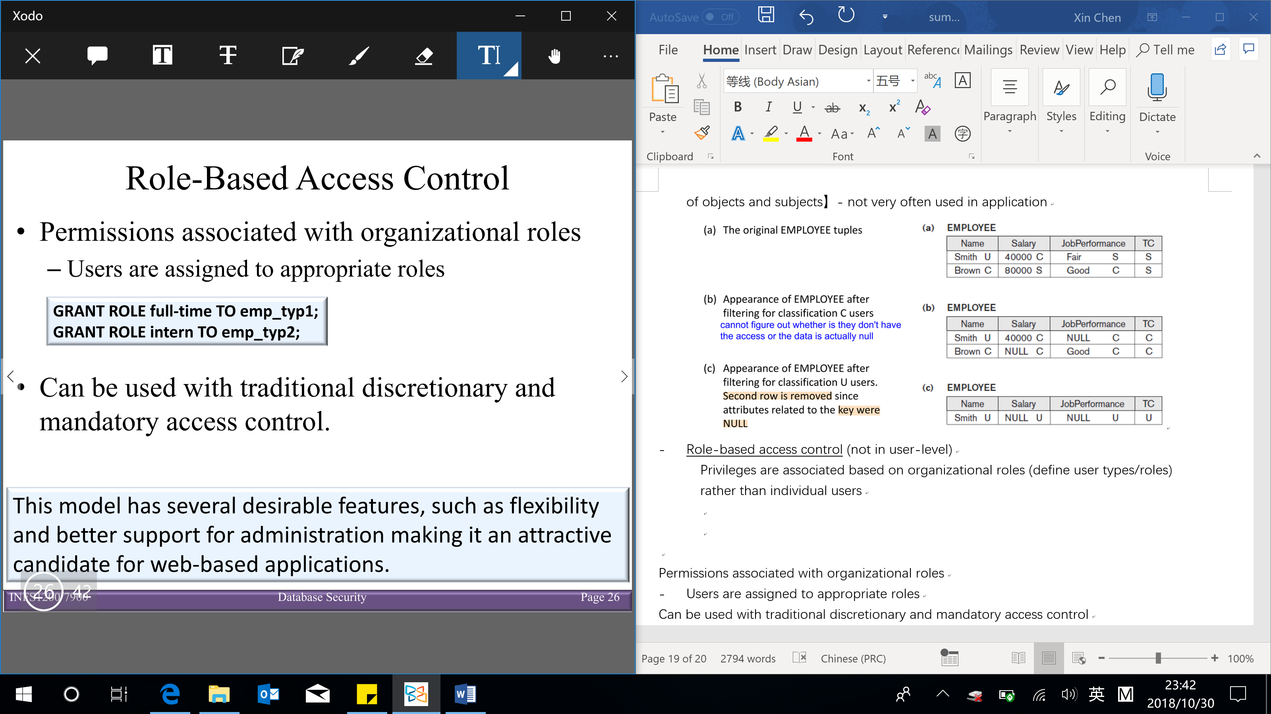

【This model has several desirable features, such as flexibility and better support for administration making it an attractive candidate for web-based applications】

**SQL injection**

* Most common threat to database system

Attacker injects a string input through the (often web/ other interface) application which changes or manipulates SQL statement to attacker’s advantage

Other common threats

* Unauthorized privilege escalation
* Privilege abuse
* Denial of service (service is there, but it won’t allow user to access)
* Weak authentication (get some information about the user, e.g. can login if having the username but don’t have password)

SQL injection methods:

* SQL manipulation

Changes an SQL command in the application

(e.g. adding conditions to the WHERE clause typical manipulation attack occurs during database login)

Example:

A simple query to check if query returns any result:

SELECT * FROM users WHERE username = ‘jake’ AND password = ‘jakespassword’ → if there is a result, give the user access to login & if not, don’t give the access to login to the system

Attacker’s manipulation:

SELECT * FROM users WHERE username = ‘jake’ AND (password = ‘jakespassword’ OR ‘x’=‘x’) → this is always True

→ now the attacker can login as ‘jake’ and perform everything that ‘jake’ is authorized to do in the database system

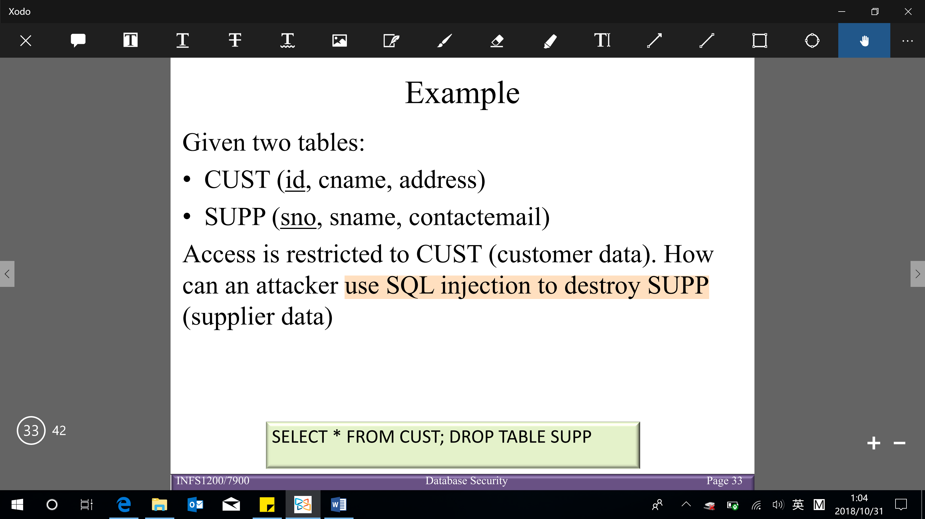



(given a place in interface to put a search or do somethings but it’s not being syntaxis and you can write whatever you want → can write SQL query in the search part → SQL query is passed on and execute on the backend)

* Code injection

Add additional SQL statements or commands that are then processed

* Function call injection

Database or operating system function call inserted into vulnerable SQL statement to manipulate data or make a privileged system call

Risks associated with SQL injection

* Database fingerprinting: attacker determines the type of database being used
* Denial of service: attacker denies service to valid users
* Bypassing authentication: attacker gains access to database without valid authorization
* Identifying injectable parameters: attacker determines information about backend structure → allow them to pass on parameters to have further attack
* Executing remote commands: attacker executes harmful commands remotely
* Performing privilege escalation: attacker upgrades their access level (once they are in)

Protection techniques

* Blind variables (using parameterized statements/ (syntaxis) parameters in statements)

Protects against injection attacks

Improves performance

* Filtering input (input validation)

Remove escape characters (space, 标点符号) from input strings

Escape characters can be used to inject manipulation attacks

* Function security

Standard and custom functions should be restricted (mostly in code not in DBMS)

Database control measures:

1. Access control (details above)
2. Inference control
3. Flow control
4. Data encryption

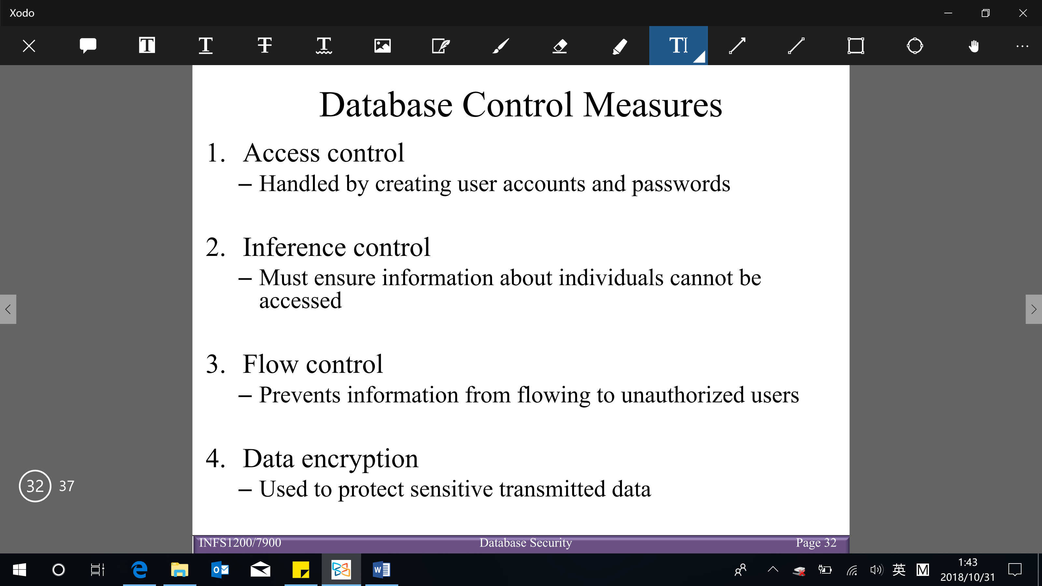

Other database control measures

* **Inference control**

Goal: provide the ability for users to get high level statistical information about the database → only statistical queries are allowed

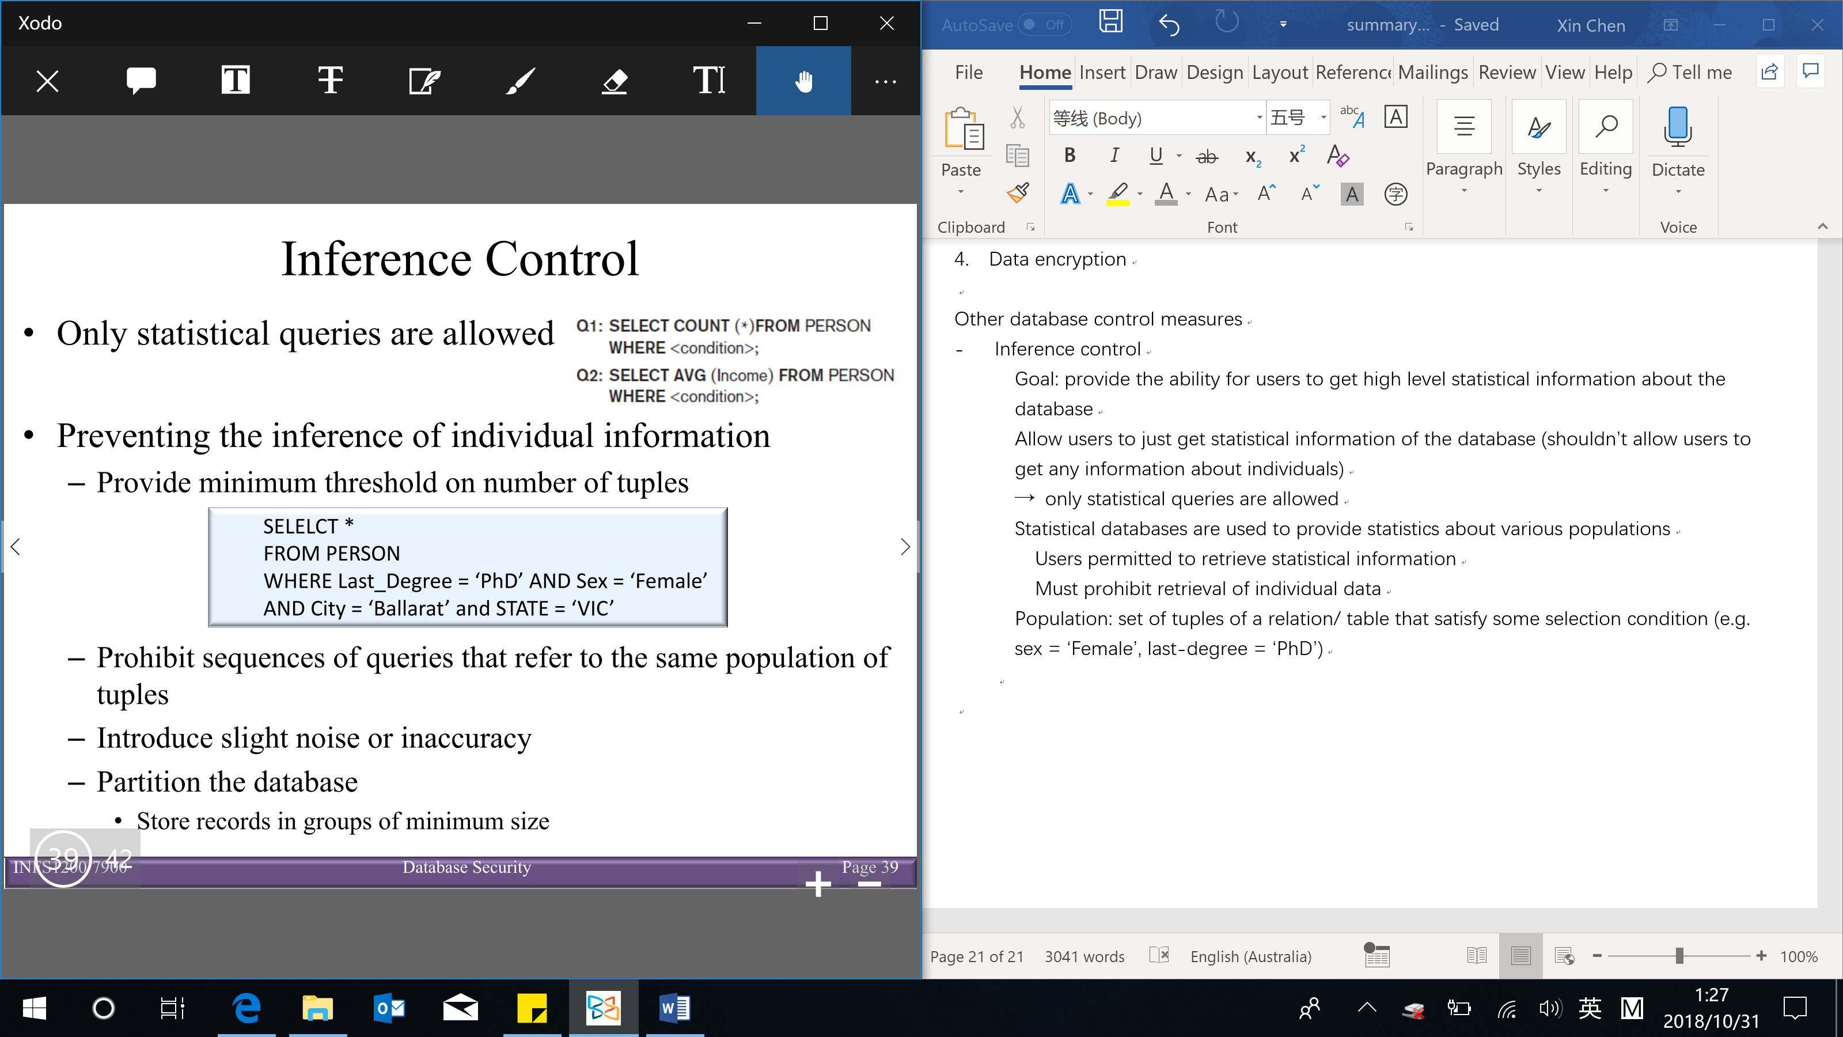

Statistical databases are used to provide statistics about various populations

Users permitted to retrieve statistical information

Must prohibit retrieval of individual data (shouldn’t allow users to get any information about individuals)

Preventing the inference of individual information:

* Provide minimum threshold on number of tuples

e.g. minimum threshold is 5 → if return less than 5 tuples → don’t show the information (as it potentially to retrieve the individual information)

* Prohibit sequences of queries that refer to the same population of tuples
* Introduce slight noise or inaccuracy in database but maintain the correct statistical data
* Partition the database – store records in groups of minimum size (have new tables that run by GROUP BY → only allow users to access those tables instead of the actual table itself)

Population: set of tuples of a relation/ table that satisfy some selection condition (e.g. sex = ‘Female’, last-degree = ‘PhD’)

* **Flow control**

Regulates the distribution or flow of information among accessible objects

Verifies information contained in some objects does not flow explicitly or implicitly into less protected objects

(avoid the ability that people to make movement from somethings they have access to make it available to people that have lower level of privilege)

Flow policy – specifies channels along which information is allowed to move (simple form: confidential and non-confidential)

* **Data encryption**

Encryption converts data into cyphertext

Performed by applying an encryption algorithm to data using a pre-specified encryption key

Resulting data must be decrypted using a decryption key to recover original data

Data encryption standard (DES) – developed by the US government for use by the general public

Advanced encryption standard (AES) – more difficult to crack